
CTW has received the following message from the Mayor:
To: Revd Rosie Webb
Chair
Churches Together in Windsor
Dear Rosie
On behalf of everyone at the Royal Borough of Windsor and Maidenhead I would like to pass on our good wishes for a very Happy Christmas to all members of Churches Together in Windsor. I hope you all enjoy the celebrations whilst recognising the true reason for the festivities. With my best wishes for a peaceful, happy and healthy 2026.
Yours sincerely
Mandy Brar
Mayor

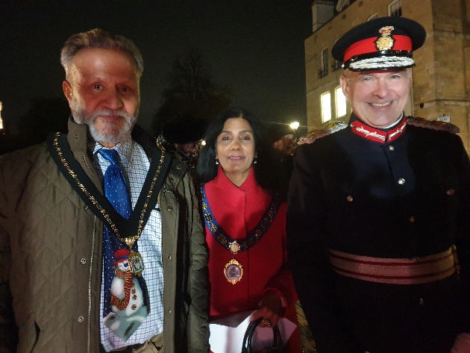
Our main CTW event held recently was Carols on the Hill on Friday 12th December at 6.15pm at the statue of Queen Victoria on Castle Hill.
This was held in the presence of HM Lord-Lieutenant of The Royal County of Berkshire, Mr. Andrew Try and The Worshipful The Mayor of The Royal Borough of Windsor and Maidenhead, Cllr Mandy Brar.

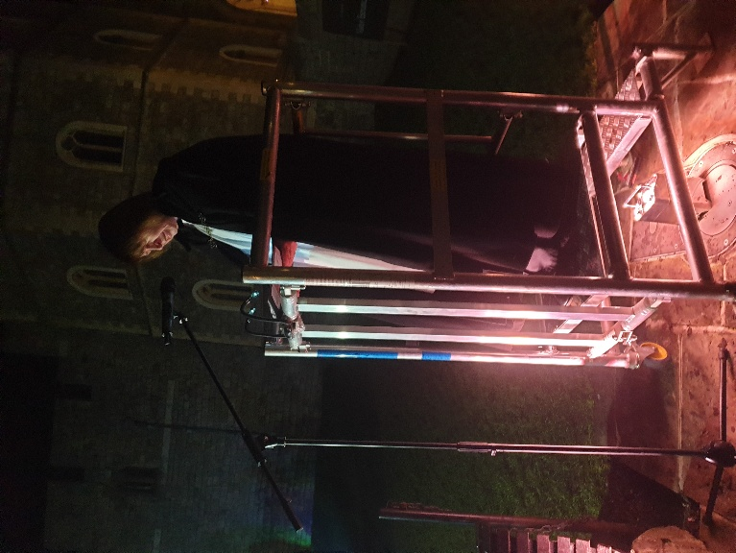

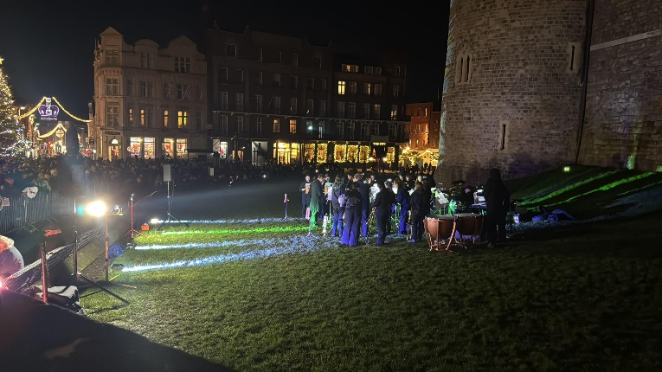
This year music was provided by The Royal Holloway University of London Brass Band.

Our collection was in aid of the charities Well Windsor and WHP Cold Weather Night Shelter.
WELL WINDSOR is a parent-led charity dedicated to improving the mental health and wellbeing of children and young people across Windsor. We fund practical support in schools including curriculum-based learning, counselling, therapy dogs and teacher training, and work to build a connected community giving children a voice, a sense of belonging and the tools to thrive. Your support makes a significant difference to young lives, and every donation takes us a step further on the journey to helping our young people thrive both today and in tomorrow’s world. Well Windsor Charity - https://www.wellwindsor.org.uk/
WHP COLD WEATHER NIGHT SHELTER
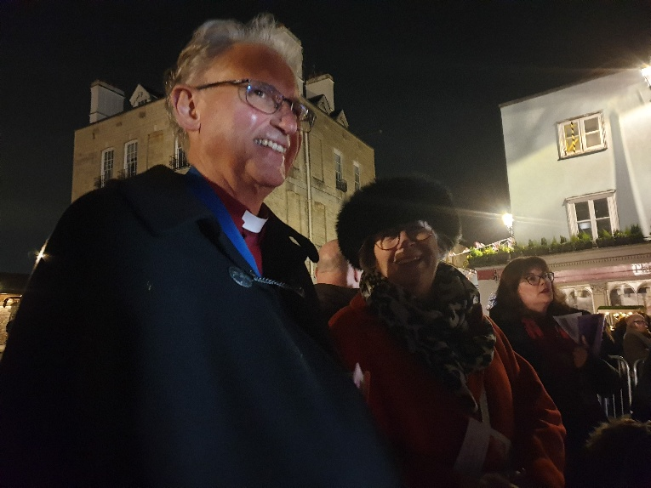
In 2013, Churches Together in Windsor formed Windsor Christian Action whose projects include Windsor Homeless Project, Windsor Street Angels and Windsor Foodshare and now operates at the Alma Beacon. In 2019 a new project – More Than a Shelter – was created to provide overnight accommodation in local churches during the winter months, eventually becoming an official part of the Windsor Homeless Project. This year it will open as the Cold Weather Night Shelter at the Alma Beacon, offering hospitality, kindness and hope to vulnerable individuals of all faiths and none when it is needed most. info@almabeacon.org The cold weather night shelter is running at Alma Beacon from 15th December to the end of March 2026. After accommodating 15 guests per night last winter, we have expanded our capacity to 20 beds per night, so fewer people will be turned away. Access to the shelter is by referral from professional services such as the RBWM Rough Sleeping Team or the police. Guests receive a hot meal, shower facilities, clean clothing if needed, a safe bed for the night and breakfast.
We are deeply grateful to the Royal Holloway University of London Brass Band, The Berkshire Lieutenancy and The College of St. George for invaluable support, The Prince Philip Trust Fund and The Rotary Club of Windsor & Eton for their generous funding, and The Royal Borough of Windsor and Maidenhead, TVP, Adams Park Security, Tactical Medical UK Paramedics, Volunteer and Charity Stewards and RBWM Ambassadors, all of whom have helped make this event possible. Our thanks also go to London Mini Coaches for transporting the Band.

Our next event is the Peace Light Service on Tuesday 23rd December 2025 at 17:00 in St Edward’s Church, Alma Road Windsor SL4 3HJ

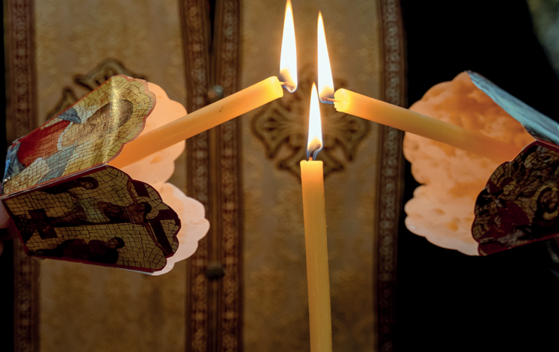
Peace Light Service

Tuesday 23rd December 2025 at 17:00
in St Edward’s Church, Alma Road Windsor SL4 3HJ

As we prepare to celebrate the Birth of Christ - ‘Light of the World’ and ‘Prince of Peace’ - please join us at 17:00pm on Tuesday 23rd December
to pray for peace in our troubled world.
The service will also be live streamed via: https://www.youtube.com/@christthekingwindsor/streams

With music, carols, readings and silence we will pray around the Peace Light brought from the Grotto of the Church of the Nativity in Bethlehem.

Please bring a lantern and candle to take the Light home with you to share among family, friends and neighbours.

Hosted by the Parish of Christ the King and supported by Churches Together in Windsor



Dates for your diary 2026:
Week of prayer for Christian Unity: 18-25 January 2026
Candlemas service: 2 Feb 2026 – Evensong at St George’s Chapel, Windsor Castle
World Day of Prayer: March 6th – service this time has been prepared by the women of Nigeria on the theme of “I will give you rest, come”
Christian Aid week: 10 – 16 May 2026
Ecumenical vespers: Friday 15 May 2026 at 6.30pm at St Edward’s
Pentecost service: May 24th: Alexandra Gardens

