Churches Together in Windsor Newsletter
Autumn 2026
CTW | Churches Together in Windsor
Please do also follow us on Facebook: https://www.facebook.com/ChurchesTogetherInWindsor
Dear Friends in Christ,
Harvest festival 2026
Welcome
The equinox has tipped us into autumn, and last weekend’s full moon was a glorious harvest moon. Although the mornings are a little chilly, we still haven’t had much rain; the days remain warm and quite humid.
Autumn seemed to begin early this year, with many trees shedding their leaves because of the lack of rain. Last Sunday, I had the privilege of talking with farmers at the agricultural show and blessing the ploughs. Ploughing competitions were under way, and two teams of horses stood ready to pull the traditional ploughs. However, the ground was so hard that it first had to be broken up; otherwise, the blades would simply have slid across the surface. Harvests have come early, crop yields have been lower, and the second growth of hay for the animals never came. As a result, farmers have had to buy hay much earlier than usual—not to mention the cost of diesel.
We have faced challenges in our own gardens and allotments. Everything in our greenhouse more or less cooked, although I just managed to keep the pumpkins and kale going. It has been a difficult growing season, yet we remain grateful for our small patch—and especially grateful to those who work the land and produce our food.
Giving thanks is something we can all share, whatever our religious background. We all need to eat, so we all share in the same harvest. However our food reaches our homes, its growth is rooted in the rhythms of sun and rain, in the rich soil of the fields, and in the delicate balance between husbandry and exploitation.
At this time of year, churches bring the gifts of nature inside: fruit and vegetables from allotments and gardens, alongside tins and packets from the supermarket. We gather to give thanks for the harvest and for the food we eat. This celebration also falls around the feast of St Francis, who reminds us that we share creation—and its harvest—with birds, animals and all living things. Conkers, acorns, beechnuts, hazelnuts and hawthorn berries provide food for creatures through the winter and the seeds of future trees, which will in turn give us oxygen. Planting anything takes time and patience. Did you know that one tree can absorb up to 1,000 kg of carbon by the time it is forty years old? Trees make the world a better place.
This week, carry a conker in your pocket and give thanks for those who work the land and for the food you have to eat and share. Collect seeds and perhaps plant some; make bird feeders, hug a tree, and thank God that we are all made to share in his wonderful creation.
Harvest thanksgiving and blessings to you all.
Revd Rosie
Key ecumenical events in the Churches Together year – all welcome!

AGM and Songs of Praise: Sunday 15th November 6pm AGM followed by Songs of Praise at 6.30pm at the Methodist Church, celebrating 150 years of Methodists in Windsor.

Carols on the Hill: Friday 11th December at 6.15pm for 6.30 pm at the statue of Queen Victoria by Windsor Castle. Come and hear the Band leading the music as we sing carols and hear Christmas readings. The event is free with a collection for two chosen charities – this year these are the Emerge Advocacy and St Vincent de Paul Christmas Lunch project.

Ecumenical Light of Peace Service: Wednesday 23rd December at 6.30pm at St Edward’s Alma Road.

Week of prayer for Christian Unity: 18th – 25th January 2027

Candlemas Evensong service: 2nd Feb 2027 at 5.30pm at St George’s Chapel

World Day of Prayer: Friday 5th March 2026: this year the service has been prepared by an ecumenical group of Christian women from the World Day of Prayer International Committee; the theme is: “United in prayer for justice and peace.”

Pentecost Picnic in the Park: Sunday 16th May 2026 at Alexandra Gardens
Windsor Christian Action/Alma Beacon
Originally a group of volunteers spearheaded by Churches Together in Windsor created an initiative to identify rough sleepers and to care for them: this Windsor Homeless Project was the nucleus of the Windsor Christian Action registered charity, which later came to include Windsor Street Angels and Windsor FoodShare as well. Alma Beacon is the operating name of the charity and provides essential support to the vulnerable members of our local community. Their Annual General Meeting is from 7–9pm on Thursday 5th November at Alma Beacon, 73a Alma Road. Please come along and find out more about their work. The Cold Weather Night Shelter opens on Monday 14 December – why not volunteer? Get Involved - Alma Beacon A charity in Windsor or email Jim Burns at james.burns@live.com

The C of E Parish of Central Windsor is planning a Come & Sing Harvest Evensong at All Saints', Frances Road on Sunday 11 October - more information and booking form at: https://www.windsorchurches.org.uk/events/church-events/come-sing-harvest-evensong/

Key events for the 150th Anniversary Year of the Methodists in Windsor:

11 October Harvest Supper 6pm with PCSO Dave Bullock talking about the work of Windsor Christian Action

29 November: 10.30am Toy service: the annual toy donation is blessed before being sent to families in need

18/19 December: Character Nativity: a walk through Nativity – meet the characters and hear their account of the greatest story ever told

20 December: 3pm Carols by candlelight

21 Feb 2027: Anniversary Service 10.30am

25 April: Praise & Protest: 5pm service with the songs of the great protest writers and a talk on what the Methodist Church is doing for social justice

25/26 June: 150 years in Windsor: the Play, written by the award-winning playwright Geoff Buckingham

10 July: An evening with Paul & Fiona; 6pm – hear the inspiring story of Paul Jones (of the Manfreds) and Fiona Hendley-Jones (TV and radio actress), a powerful testimony in word and song

17 July: Closing celebration: evening meal and fun quiz

Dedworth Green Baptist Church, Smiths Lane, Windsor, SL4 5PE Back to Basics course
Have you ever wondered what Christians believe? Do you have questions you would like to ask? Then this course is for you. A safe place to ask questions; to discuss and affirm beliefs; to share stories and find out more about the Bible. Starting on Wednesday 7th October 2026 at 7.30pm (7.15pm for tea/coffee), the course will be held on the first Wednesday of each month. If you are interested, speak to Jenny Soles or Carol Edwards or email info@dgbc.org.uk

St Andrews Clewer
- St Andrews Day Christmas Fair - 28th Nov
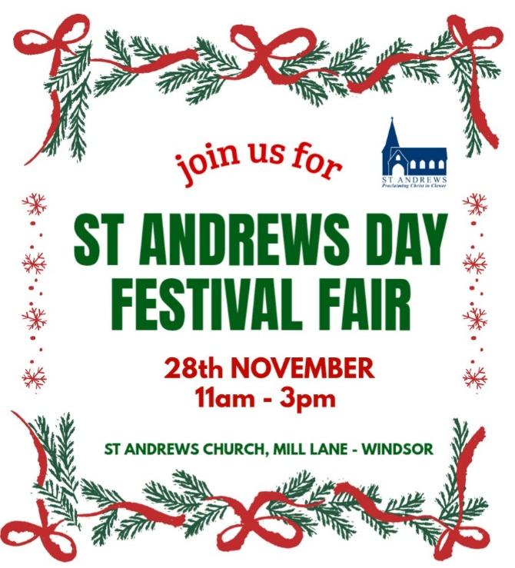

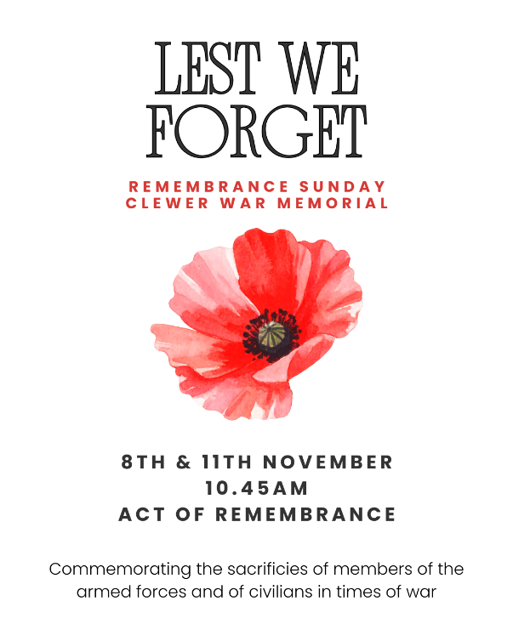
- Remembrance Day Clewer War Memorial - 8th & 11th Nov

- Friday Fun Hub during half term


- October and November Wild Worship Events

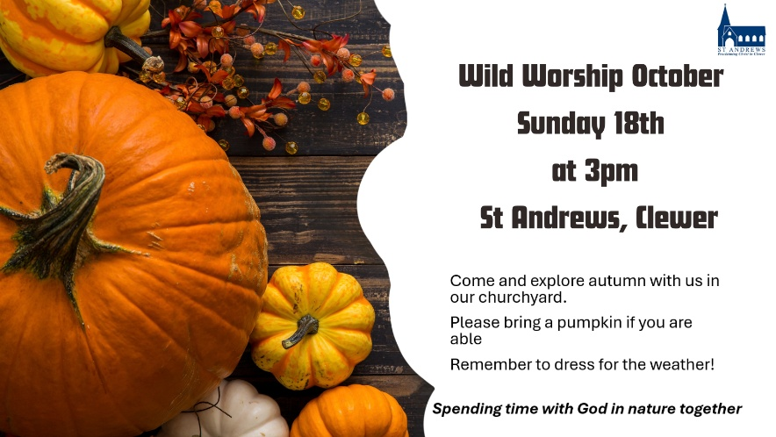
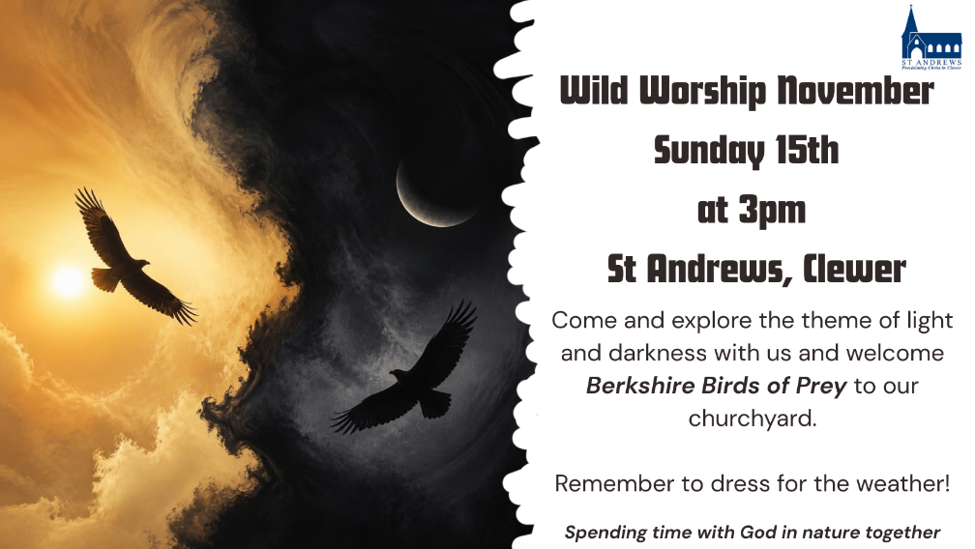

- Vacancy for a foundation governor at Clewer Green First School
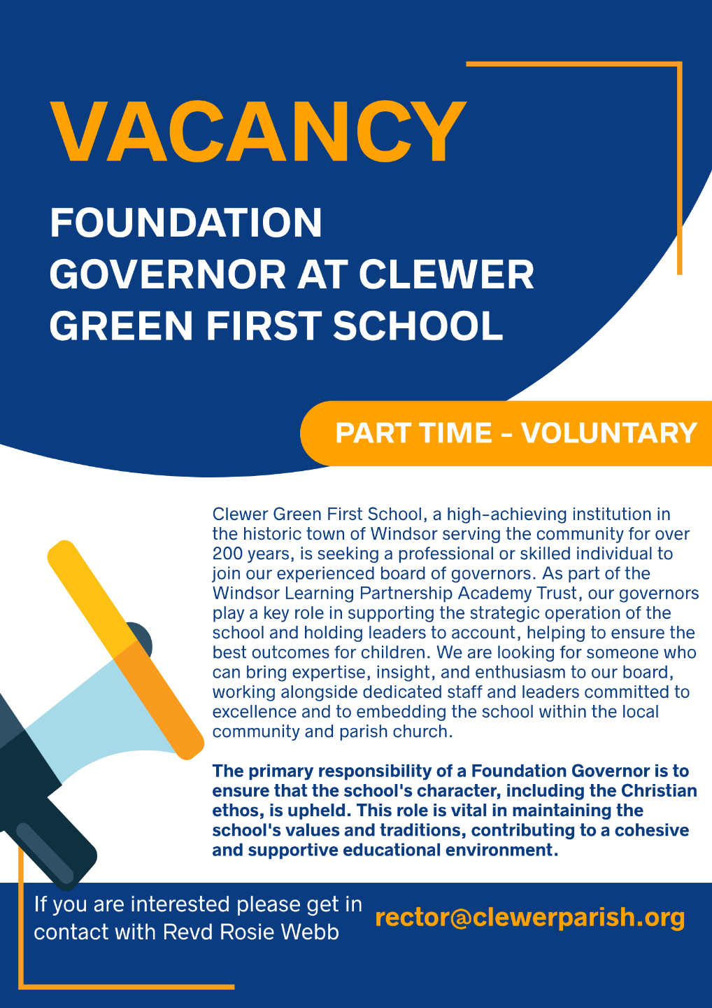

Windsor Local History Group OPEN DAY SATURDAY 14th NOVEMBER 2026 at WINDSOR BAPTIST CHURCH, VICTORIA STREET SL4 1EH. Open from 11am to 4pm – FREE ENTRY! Everyone welcome! Refreshments available.

Now a well-established WLHG tradition, this year’s annual “Open Day” will also provide an exceptional opportunity to mark the group’s Fiftieth Anniversary with special exhibits in addition to a wide range of maps, photographs, letters, videos, displays and artefacts, offering visitors an invaluable opportunity to engage with the fascinating heritage of Windsor and many of its surrounding towns and villages. This FREE event is open to everyone and will take place on Saturday 14th November, Windsor Baptist Church, Victoria St SL4 1EH, 11am-4pm. A great experience for anyone interested in learning more about Windsor! WLHG Open Days provide fascinating cultural snapshots of the town and wider area stretching back as far as Saxon and Norman times. The latest edition (No.40) of “Windlesora”, WLHG’s annual magazine will be available soon -- still priced at £5! Past editions of Windlesora, second-hand books and other publications will be on sale along with cards, maps and books published by the Friends of the Windsor &amp; Royal Borough Museum. Please feel free to bring along your own memorabilia too – we’d love to hear your own stories and research! For more information, please visit our website https://windsorlocalhistorygroup.org/

Contact details for the churches are as follows:
CHURCH OF ENGLAND CHURCHES
Windsor Parish Church: Parish Church of St John the Baptist
The High Street, Windsor SL4 1LT
Telephone: 01753 862419
Minister: The Revd Canon Sally Lodge
E-mail: team@windsorchurches.org.uk
Website: www.windsorparishchurch.org.uk
Services: Eucharist: SUNDAY: 10.00am for one hour (rotates between St Stephen & St Agnes; Holy Trinity; All Saints' and Windsor Parish Church)
https://www.facebook.com/Windsorparishchurch

All Saints’ Church
Frances Road, Windsor, SL4 1HU
Telephone: 01753 862419
Minister: The Revd Canon Sally Lodge
E-mail: team@windsorchurches.org.uk; windsor.rector@gmail.com
Website: www.allsaintswindsor.org.uk
Services Eucharist: SUNDAY: 10.00am for one hour (rotates between St Stephen & St Agnes; Holy Trinity; All Saints' and Windsor Parish Church)
https://www.facebook.com/allsaintschurchwindsor

Holy Trinity (Parish and Garrison Church),
Claremont Road & Trinity Place, Windsor, SL4 3AX
Telephone: 01753 862419
Minister: The Revd Canon Sally Lodge
E-mail: holytrinitychurchwindsor@gmail.com
Website: holytrinitywindsor.org.uk
Services: Eucharist: SUNDAY: 10.00am for one hour (rotates between St Stephen & St Agnes; Holy Trinity; All Saints' and Windsor Parish Church)
https://www.facebook.com/htgcwindsor

St Stephen & St Agnes, Clewer
Vansittart Road, Windsor, SL4 5EA
Telephone: 01753 862419
Minister: The Revd Canon Sally Lodge
E-mail: team@windsorchurches.org.uk
Website: www.ststephenwindsor.org.uk
Services: Eucharist: SUNDAY: 10.00am for one hour (rotates between St Stephen & St Agnes; Holy Trinity; All Saints' and Windsor Parish Church)
https://www.facebook.com/ststephensclewer

All Saints’ Church
Dedworth Road, Windsor, SL4 4JW
Telephone: 01753 569037
Minister: Revd. Paul Walker
E-mail: via website contact us page (http://allsaintschurchdedworth.com/contact/)
Website http://www.allsaintschurchdedworth.com/
Services: SUNDAY: 9.15am – Traditional Service with Communion; 11.00am – Family Service
https://www.facebook.com/allsaintschurchcentrededworth

St Andrew’s Clewer
Mill Lane, Windsor, SL4 5JH
Telephone: St Andrews Rectory 01753 852334
Minister: Revd. Rosie Webb
E-mail: rector@clewerparish.org; office@clewerparish.org
Website: http://www.standrewsclewer.org
Services: Eucharist: SUNDAY: 10.30am, and other service times available on website
https://www.facebook.com/standrewsclewer

St George’s Chapel
Windsor Castle, Windsor, SL4 1NJ
Telephone: 01753 848888; recorded information line 01753 865538
Minister: Dean and Canons of Windsor
E-mail: chapteroffice@stgeorges-windsor.org
Website: http://www.stgeorges-windsor.org/
Services: WEEKDAYS: Holy Communion 8am; Evensong 5.15pm
SUNDAYS: Holy Communion 8.30am; Mattins and sermon 10.45am
https://www.facebook.com/stgeorgeswindsor

Grace Church Windsor (Anglican Mission in England)
c/o Christ Church URC, William St, Windsor, SL4 1BA
Telephone: 01753 257868
Minister: Vacant
E-mail: hello@gracechurchwindsor.org
Website: www.gracechurchwindsor.org
Services: SUNDAY: 4pm
https://www.facebook.com/gracechurchwindsoruk

NON-DENOMINATIONAL CHRISTIAN CHURCH
Kings Church International
Office: King's House, 77a Frances Road, Windsor, SL4 3AQ
Telephone: 01753 832444
Ministers: Pastors Wes & Adriana Richards
E-mail: hello@kcionline.org
Website: kcionline.org
Services: SUNDAY: service 10am online THURSDAY evening weekly prayer meetings online
https://www.facebook.com/kingschurchinternational

KERITH COMMUNITY CHURCH
Unit 3B, Fairacres Industrial Estate,
Dedworth Rd, Windsor SL4 4LE
Telephone: 01344 862699
Minister: Leon Johnson
E-mail: info@kerith.church, leon.johnson@kerith.church
Website: https://kerith.church/
Service: SUNDAY 10am
https://www.facebook.com/KerithWindsor

ROMAN CATHOLIC CHURCHES
St. Edward’s Church
44 Alma Road, Windsor, SL4 3HJ
Telephone: 01753 865163
Minister: Monsignor David Hopgood
E-mail: canondavid@catholicwindsor.org
Website: http://catholicwindsor.org/
Services: SATURDAY: Mass 6.00pm
SUNDAY: Mass: 11.00am.
TUESDAY: Mass: 6.30pm
WEDNESDAY: Mass: 10.00am
THURSDAY: Mass: 10.00am
FRIDAY: Mass: 12.00am (weekday service times may change due to funerals etc)
https://www.facebook.com/stedwardswindsor

St Mark’s Church
Dedworth Road, Windsor, SL4 4JS
Telephone: 01753 865163
Minister: Monsignor David Hopgood
E-mail: canondavid@catholicwindsor.org
Website: http://catholicwindsor.org/
Services: SUNDAY: Mass 9.30am

BAPTIST CHURCHES
Dedworth Green Baptist Church,
Smiths Lane, Windsor, SL4 5PE
Telephone: 01753 832002
Minister: Vacant
E-mail: secretary@dgbc.org.uk, info@dgbc.org.uk
Website: http://www.dgbc.org.uk/
Services: SUNDAY: 10.30am
https://www.facebook.com/DGBCWindsorUK

Windsor Baptist Church,
Victoria Street, Windsor, SL4 1EH
Telephone: 07971 298158
Minister: Revd. Kat Bracewell
Community Manager: Kate Saunders wbckate@gmail.com
E-mail windsorbaptists@yahoo.co.uk; kathryn.bracewell@yahoo.co.uk
Website https://windsorbaptistchurch.org.uk
Services: SUNDAY 10.30am
https://www.facebook.com/windsorbaptist

UNITED REFORMED CHURCH
Christ Church
William Street, Windsor, SL4 1BA
Telephone: 07588499386
Minister: Revd Chris Parker
E-mail: administrator@windsorurc.org
Website: http://www.windsorurc.org.uk/
Services: SUNDAY: 10.30am (also on zoom – see website for details)

METHODIST CHURCH
Alma Road, Windsor, SL4 3HH
Telephone: 01753 536357
Minister: Revd. Vicci Davidson
E-mail: rev.vicci@mail.com
Website: http://www.windsormethodist.church/
Services: SUNDAY Morning service 10.30am and Evening service 6.30pm, except the first Sunday of each month, when we have ‘Breakfast Church’ at 9am, and ‘TeaTime for the Soul’: a short traditional service that is dementia friendly, followed by tea and cakes, starting at 3pm.
https://www.facebook.com/profile.php?id=100064930801235

