Churches Together in Windsor
CTW | Churches Together in Windsor
Newsletter
Autumn 2023

Please do also follow us on Facebook: https://www.facebook.com/ChurchesTogetherInWindsor

Message from the Chair:
Dear Friends in Christ,
It’s been an interesting summer with the weather! Some holidays have been a wash out, days at the seaside cancelled, vegetables struggle with the earlier dry heat, drenching rain and heat again now in September. I hope you have managed to have some form of break over the summer, home or away, or perhaps early autumn is your time for a break?
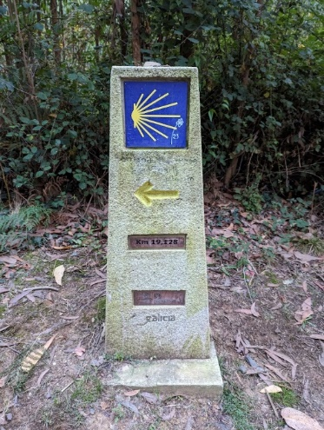
I have just returned from a walking retreat, walking the Camino to Santiago, the Way of St James in Northern Spain. Apart from rain on the first day of walking, the weather was a kind 24 degrees, certainly cooler than the UK. Every morning hostel and hotel doors open and people emerge wearing a variety of back packs, boots and walking sticks, all wearing the symbolic pilgrim shell and all head off in the same direction…following the yellow arrow to start their day’s walk.
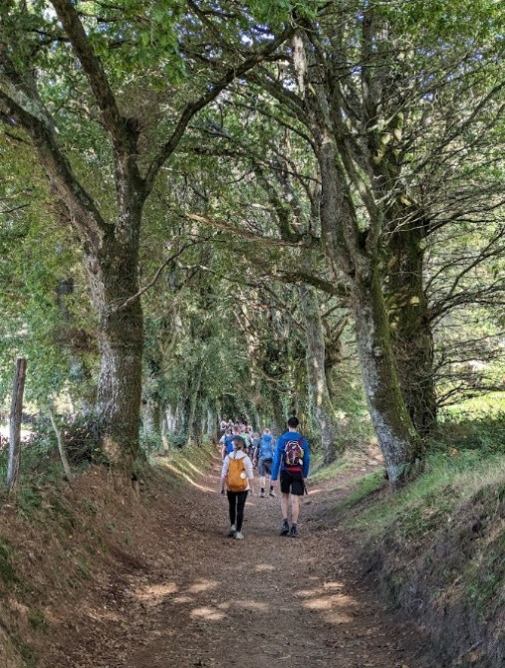
After the death of Jesus, St James the disciple took his ministry to the Iberian Peninsula and to this day is considered the Patron Saint of Spain. And he is recorded as being the first martyr amongst all the disciples of Jesus. The body of St James was taken to Compostela, where his grave is very famous and has become one of the chief pilgrimage destinations. Multitudes of pilgrims from all parts of the world go there to pray. Having been a fisherman in Galilee and having taken the road that helped him discover his spirit, the Scallop Shell is the emblem of St. James and its symbolism relate to two layers of the human condition; the physical and the spiritual. St. James was an ordinary pilgrim like the rest of us. He walked a long difficult road with Jesus; he was imprisoned by his emotions, and he went through all kinds of struggles to free himself and discover the hugeness of his spirit. He learned how to live an authentic, peaceful life and he shared his personal lessons with others.
People have walked the pilgrim’s journey in the way of St. James to Santiago de Compostela starting at different points. Some walk slowly, others challenge themselves by walking fast and giving themselves goals. Some ride bicycles, and some go on horseback, wheelchairs and toddler buggies. There are those who walk the Camino in stages, and others who walk a little and bus a little. This is not unlike the path we traverse in life. My sister and I walked the last part from Sarria to Santiago, 117km and on arrival we were just 2 of the over 800 pilgrims to register at the pilgrims post office that day.
On the spiritual levels, we are all undertaking our own unique journeys, governed by the lessons that we need to learn, and the people that we are evolving into. No two pilgrims are alike, and though we may walk the same roads on the outside, our inner pathways wind through very different emotional landscapes.
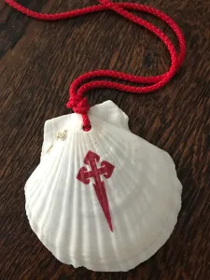
The Scallop Shell has many grooved lines that lead from the outer rim to a meeting point at the base. The shell itself represents the many different spiritual/religious pathways that lead to the same place, to the universal centre of all life-forms, the spirit, the soul. At St Andrews we use the scallop shell to pour the waters of baptism for this reason. When pilgrims that walk the Camino carry the Scallop Shell it represents their personal journey, the sacred path that we all must take within. We are all on the outer rim of the spirit, struggling to find our way back to God, our centre. The Scallop Shell reminds us why we are walking, especially at the points when the journey feels too hard and we want to give up. It reminds us to focus on our journey only, and that each person has their own journey to travel and own story that is unfolding. It reminds us that we are all ultimately one sacred soul and that each of our roads leads us back to each other.
Isn’t it amazing that St James is still leading people to Jesus!
Buen Camino
Revd Rosie, Rector of Clewer, Chair of CTW
Call for a volunteer to help WCA:
Windsor Christian Action
Job Description: WCA Membership Secretary

Context: Windsor Christian Action (WCA) is a small (but increasingly busy) not for profit charity which is responsible for three Projects, namely: 1) Windsor Homeless Project; 2) Windsor Street Angels; and 3) Windsor Foodshare. The general purposes of the charity are to provide practical and emotional support to vulnerable people in the locality (including those who have become homeless), and to provide resources which might enable them, where necessary, to rebuild their lives. We are entering an exciting phase in our development, having recently acquired our own premises in Alma Road, central Windsor.

The Role: This is a part-time voluntary administrative role, working from home. It is an important role, as the members occupy a central position in the charity's constitution, not only by voting on resolutions at the AGM but also providing the Trustees and volunteers with their support.

Working Hours & Conditions: 4 hours per month; also attending annual AGM.

Tasks, Duties & Responsibilities:

Administration:
- Keep membership records up to date
- Ensure that members pay their membership fees, reminding them if necessary
- Recruit and enrol new members – volunteers, businesses, corporates, churches, and other supporters.

Communication:
- Communicate regularly with members, to keep them informed and motivated
- Liaise with trustees to inform them about membership matters

If you are interested in the above position, please contact Jane Deakin on:
secretary@windsorchristianaction.org, or phone 07972 646613. Thank you.

News from the Churches:
From Windsor Methodist Church: Our Sunday School kept going during the Summer and enjoyed a picnic in August.

For your diary:
8th September and continuing
The fortnightly meeting for teenagers entitled "Geese" re-starts at Windsor Methodist Church. This is a Bible study and discussion group with Pizzas. This meeting meets on alternate weeks with the youth club for the 11+ age group. Both meetings begin at 6pm. Visiting youngsters are welcome at each of these meetings.

17th September at 6pm
Taizé-style Holy Communion at St Stephen & St Agnes Church. All welcome.

Saturday 23rd September from 10am
Harvest Market in the churchyard at St Andrews Clewer. Food4Food, Local4Local. Local growers and allotment holders are bringing their produce, local homemade jams and chutneys, local honey and baked goods – all donations to raise funds for the WCA FOODSHARE project. Refreshments available, market opens at 10am.

Sunday 24th September at 10.30am
Dedworth Green Baptist Church: family-friendly Harvest celebration

30th September 6.30pm for 7pm
Quiz Night in aid of Windsor Christian Action, 73a Alma Road Project.
Parish Hall at All Saints’ Church, Frances Road, SL4 1HU. £10 per person, includes Harvest Supper.
Book as a team of 6 or 8, or come by yourself and join a team on the night. Licensed bar.
Please book in advance: windsor.churchbookings@gmail.com
1st October 10.30am
Harvest Festival at St Andrews Clewer.

1st October at 7pm
Organ Recital at Windsor Parish Church. Leading international concert organist, Thomas Trotter, re-launches the recently restored three-manual pipe organ in a concert designed to highlight the instrument’s varied tonal palette and power. Bookings through Thomas Trotter: Inaugural Recital on rebuilt Organ (windsorfestival.com)

Saturday 7th October 3.45 to 6pm
Windsor Methodist Church messy church afternoon.

8th October at 5pm
Joint Harvest Choral Evensong at All Saints Francis Rd, singers welcome to join the choir.

Saturday 21st October 7.00 for 7.30pm
A CONCERT at Windsor Methodist Church by the award winning Christian singer/songwriter Rob Halligan. Tickets £7-50 (under 18s free) from Phil Mount (philmount@aol.com) or pay on the door.

Thursday 16th November 7.45pm
Churches Together in Windsor short AGM and social time at Windsor Methodist Church.

Saturday 2nd December: 2.30pm
Christmas Concert and Organ Recital at Windsor Methodist Church with our minister Vicci Davidson and the renowned organist Paul Leddington-Wright.

Advent
If you are holding any discipleship courses during Advent, please let us know so we can spread the word and pray for you.

Friday 8th December 6:15-7:30pm CTW CAROLS ON THE HILL
Celebrating the true Christmas Spirit in Windsor
Following record turnouts for "Carols On The Hill" in 2021 and 2022 after a hiatus during the covid lockdown, this ever popular event will take place in the presence of The Worshipful The Mayor of RBWM, Cllr Neil Knowles and The Mayoress Mrs Knowles, and featuring The Band of The Household Cavalry by kind permission of Major General James Bowder OBE, Major General Commanding The Household Division (from October 2023).
Starting off with a sparkling "Seasonal Medley" as part of the Windsor and Eton "Living Advent Calendar", this much loved local Band will accompany the traditional Carol Service complemented by the atmospheric view of Windsor Castle, brightly lit Christmas tree and statue of Queen Victoria. Led by Rev Sally Lodge, with Readers representing different Windsor churches and organisations, the Service will also include a well supported street collection shared between two charities serving the town and wider community and introduced by The Mayor.
The precedent for "Carols On The Hill" stretches back to December 1949 when a Christmas tree was erected and illuminated for the first time near Queen Victoria's Statue with the castle as its backdrop, providing a charming focal point for Windsor and Eton Rotary Club's efforts to gather and distribute hundreds of gifts for children in various hospitals. Shortly before Christmas, a group of Rotary Club carol singers gathered around the tree to sing hymns and carols with a large audience that included The Mayor, thus laying the foundations for this important Windsor tradition which has continued almost unbroken throughout the intervening seven decades.
Churches Together in Windsor would like to express their sincere gratitude for support from all the town's churches; The Band of The Household Cavalry; the Rotary Club of Windsor & Eton; The Prince Philip Trust Fund (incorporating The Royal Albert Institute Trust); WE&A Town Centre Management; RBWM; TVP and local volunteers; as well as London Mini Coaches for transporting The Band.
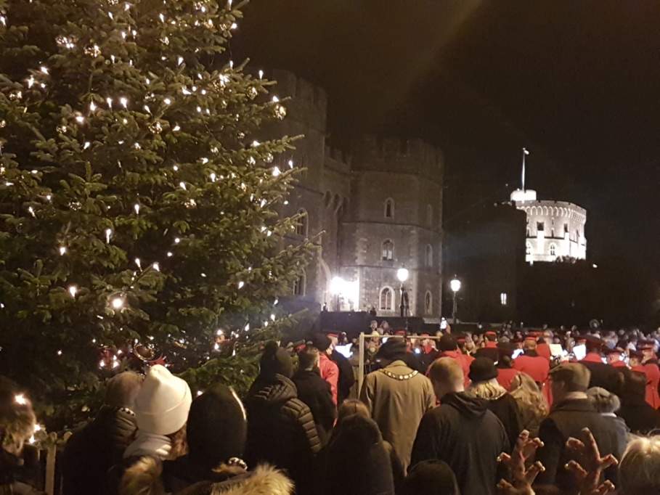

Saturday 9th December: 11am-2pm
Live Nativity (instead of messy church) at Windsor Methodist Church.
Ongoing activities:
Messy Church:
Dedworth Green Baptist Church: 2nd Sunday of the month, 3.00 - 5.30pm
Methodist Church: Saturday afternoon (3.45 to 5.30 pm) in school holidays: includes craft activities, a short, fun act of worship and a meal. All are welcome. Children to be accompanied by an appropriate adult.

Dedworth Green Baptist Church
‘The WellSpring’, our Renew Wellbeing centre, is open at the church from 09.45am – 12.15pm every Tuesday as a safe place where it’s ‘okay not to be okay’. Crafts, chat and coffee, with a prayer space available for those who would appreciate it.

Methodist Church
We continue to hold a 'Teatime for the Soul' service on the first Sunday each month at 3pm. These increasingly popular services are aimed at those who find it difficult to come to church for 10-30am and are dementia friendly. They are about half an hour long with traditional, familiar hymns and a short message followed by tea and cakes downstairs in the hall. It has been a joy to see some of our older members who have not been back to church since the start of the pandemic. All are welcome, whether members of a church or none.
Sunday Evening Service, 6.30pm to 7.30pm. These are friendly, peaceful, spiritual Services including prayers, Bible readings and a Sermon. One each month is a ‘Café Style’ Service which often include interesting discussions. Our numbers of attendees vary, but normally about 12 of us. Any friends would be warmly welcomed!

The Methodist Church would also warmly welcome friends to Prayer Group meetings which are 1-1.30pm (not 6pm to 6.30pm as incorrectly stated previously) on alternate Wednesdays in the Cornerstone Chapel, which is the door nearest the traffic lights. Dates are published on the website and in the weekly newsletter which is circulated electronically. If you would like to receive the Methodist newsletter, please email our Church Council Secretary at rosemarycracknell@btinternet.com Prayers are said for Christian growth in our Windsor Churches, our community, and anything else folks may be prompted to pray for.

Toddlers’ Group each Thursday (term time) welcomes all Toddlers with an appropriate adult from 09.15 to 11.15am at the Methodist Church.

St Andrews Clewer
Wild Worship on third Sunday of the month, 3pm in St Andrews churchyard, all ages welcome.

Dementia friendly events:
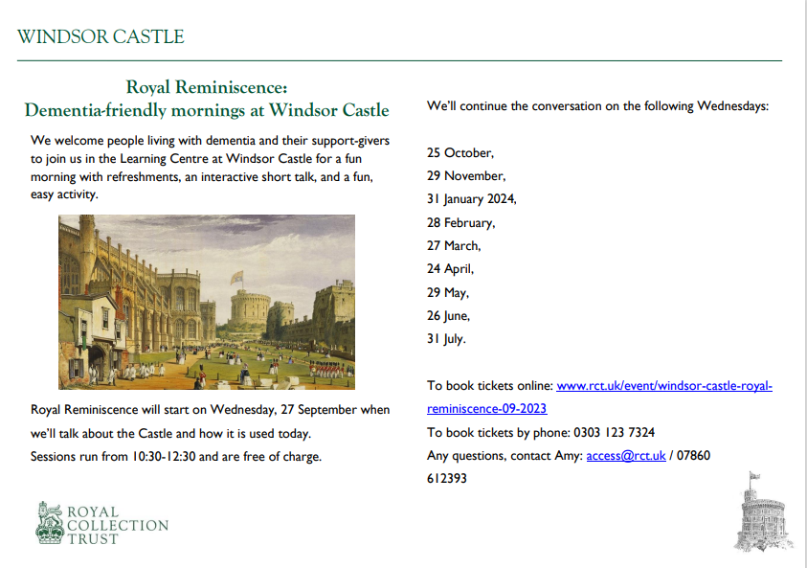
Contact details for the churches are as follows:

CHURCH OF ENGLAND CHURCHES
Windsor Parish Church: Parish Church of St John the Baptist
The High Street, Windsor SL4 1LT
Telephone: 01753 862419
Minister: The Revd Canon Sally Lodge
E-mail: team@windsorchurches.org.uk
Website www.windsorparishchurch.org.uk
Services: Eucharist: SUNDAY: 10.00am for one hour (rotates between St Stephen & St Agnes; Holy Trinity; All Saints' and Windsor Parish Church)
All Saints’ Church
Frances Road, Windsor, SL4 1HU
Telephone: 01753 862419
Minister: The Revd Sally Lodge
E-mail: team@windsorchurches.org.uk; windsor.rector@ gmail.com
Website www.allsaintswindsor.org.uk
Services Eucharist: SUNDAY: 10.00am for one hour (rotates between St Stephen & St Agnes; Holy Trinity; All Saints' and Windsor Parish Church)
Sunday Xtra: Short, informal, contemporary, all age worship: 2nd and 4th SUNDAY 10.00am

Holy Trinity (Parish and Garrison Church),
Claremont Road & Trinity Place, Windsor, SL4 3AX
Telephone 01753 862419
Minister: The Revd Canon Sally Lodge
email holytrinitychurchwindsor@gmail.com
Website holytrinitywindsor.org.uk
Services: Eucharist: SUNDAY: 10.00am for one hour (rotates between St Stephen & St Agnes; Holy Trinity; All Saints' and Windsor Parish Church)

St Stephen & St Agnes, Clewer
Vansittart Road, Windsor, SL4 5EA
Telephone: 01753 862419
Minister: The Revd Canon Sally Lodge
E-mail: team@windsorchurches.org.uk
Website: www.ststephenwindsor.org.uk
Services: Eucharist: SUNDAY: 10.00am for one hour (rotates between St Stephen & St Agnes; Holy Trinity; All Saints' and Windsor Parish Church)

All Saints’ Church
Dedworth Road, Windsor, SL4 4JW
Telephone: 01753 841710
Minister: Revd. Paul Walker
E-mail: via website contact us page (http://allsaintschurchdedworth.com/contact/)
Website http://www.allsaintschurchdedworth.com/
Services: SUNDAY: 9.15 am – Traditional Service with Communion; 11.00am – Family Service
St Andrew’s Clewer,
Mill Lane, Windsor, SL4 5JH
Telephone: St Andrews Rectory 01753 852334
Minister: Revd. Rosie Webb
email: rector@clewerparish.org; office@clewerparish.org
Website: http://www.standrewsclewer.org
Services: Eucharist: SUNDAY: 10.30am

St George’s Chapel
Windsor Castle, Windsor, SL4 1NJ
Telephone: 01753 848888; recorded information line 01753 865538
Minister: Dean and Canons of Windsor
email chapteroffice@stgeorges-windsor.org
Website: http://www.stgeorges-windsor.org/
Services: WEEKDAYS: Holy Communion 8am; Evensong 5.15pm
SUNDAYS: Holy Communion 8.30am; Mattins and sermon 10.45am
Windsor Fellowship Church
Christ Church URC, William St, Windsor SL4 1BA Telephone: 01753 257868
Minister: Rev Tim Hiorns
E-mail: hello@windsorfellowship.com
Website: www.windsorfellowship.com
Services: SUNDAY: 4pm

NON-DENOMINATIONAL CHRISTIAN CHURCH
Kings Church International
Office: King's House, 77a Frances Road, Windsor, SL4 3AQ
Telephone: 01753 832444
Ministers: Pastors Wes & Adriana Richards
E-mail: hello@kcionline.org
Website: kcionline.org
Services: SUNDAY: service 10am online THURSDAY evening weekly prayer meetings online

KERITH COMMUNITY CHURCH
Unit 3B, Fairacres Industrial Estate,
Dedworth Rd, Windsor SL4 4LE
Telephone: +44 (0) 1344 862699
Minister: Leon Johnson
E-mail: info@kerith.church, leon.johnson@kerith.church
Website: https://kerith.church/
Service: SUNDAY 10am

BAPTIST CHURCHES
Dedworth Green Baptist Church,
Smiths Lane, Windsor, SL4 5PE
Telephone: 01753-832002
Minister: Revd. Matthew Scott
E-mail: minister@dgbc.org.uk, secretary@dgbc.org.uk
Website: http://www.dgbc.org.uk/
Services: SUNDAY: 10.30am

Windsor Baptist Church,
Victoria Street, Windsor, SL4 1EH
Telephone: 07971 298158
Minister: Revd. Kat Bracewell
Community Manager: Kate Saunders wbckate@gmail.com
E-mail windsorbaptists@yahoo.co.uk; kathryn.bracewell@yahoo.co.uk
Website https://windsorbaptistchurch.org.uk
Services: SUNDAY 10.30am

ROMAN CATHOLIC CHURCHES
St. Edward’s Church
44 Alma Road, Windsor, SL4 3HJ
Telephone: 01753 865163
Minister: Canon David Hopgood
E-mail: canondavid@catholicwindsor.org
Website: http://catholicwindsor.org/
Services: SATURDAY: Mass 6.00pm
SUNDAY: Mass: 11.00am.
TUESDAY: Mass: 6.30pm
WEDNESDAY: Mass: 10.00am
THURSDAY: Mass: 10.00am
FRIDAY: Mass: 12.00am (weekday service times may change due to funerals etc)

St Mark’s Church
Dedworth Road, Windsor, SL4 4JS
Telephone: 01753 865163
Minister: Canon David Hopgood
E-mail: canondavid@catholicwindsor.org
Website: http://catholicwindsor.org/
Services: SUNDAY: Mass 9.30am

UNITED REFORMED CHURCH
Christ Church
William Street, Windsor, SL4 1BA
Telephone: 01753 862007
Minister: Revd. Alan Wickens
E-mail: revawickens@gmail.com
Website http://www.windsorurc.org.uk/
Services: SUNDAY: 10.30am (also on zoom – see website for details)

METHODIST CHURCH
Alma Road, Windsor, SL4 3HH
Telephone: 01753 536357
Minister: Revd. Vicci Davidson
E-mail rev.vicci@mail.com
Website: http://www.windsormethodist.church/
Services: SUNDAY Morning service 10.30am
Evening service 6.30pm

