Churches Together in Windsor
Newsletter
Spring 2023
Message from the Chair:
Dear Friends: Alleluia, Christ is risen!
Somehow we have been through Holy Week, Easter day and now heading towards Ascension and Pentecost at what seems like an alarming rate! Some may think Easter is over but we are in a point of time in the liturgical calendar called- the great 50 days of Easter. We have a large banner along the wall at St Andrews and not a year goes by without someone asking us to take it down because Easter is over! We are in fact Easter people every day!
All the churches in our town continued to share the Easter message in a variety of ways as is our custom, and together, the Good Friday walk of witness was reintroduced and is now firmly fixed in the Town's diary for the future. Our next 'together' event will be Thy Kingdom Come season, from Ascension to Pentecost. This is our annual opportunity, over 10 days, to pray, together, for each other, for specific people in our lives, for God's love to be made know in our community, for God's kingdom to come. Please make sure you share the calendar of events and support where you can. And our next 'together' service will be held at Windsor Methodist on Pentecost Sunday, our coming together to celebrate the season.
I'd also like to draw your attention to the sculpture on display up at the Parish church in town. It is an almost life size sculpture of the Last Supper, by Peter Barnes, and is visiting our town for a few months. The sculpture is covered in a mosaic of computer keys, over 55,000! The keys are placed in patterns and feels a bit like a word search in places, as you follow the pattern and discover lines that hold key biblical text, I managed to find 'I am the resurrection and the life'. But, for me, the most wonderful thing about the sculpture is how the arrow keys seem to gather and flow in lines towards the centre figure, Jesus. The keys then form a circle, all the arrows point inwards and to the central 'heart' of Jesus, and keys inside the circle are made up of 'home' keys.
Churches Together in Windsor is made up of such a wonderful variety of Christians, we are all different keys on the same key board, all with different uses, but we all point in the same direction- towards Jesus Christ our Saviour- our home key.
Here is a reminder of what CTW is all about:
Enabling Member Churches to develop mutual relationships, find common ground, work together to build God's Kingdom, live and share the Gospel, evangelise together, take further steps towards fuller unity, respond to the needs of society and witness to the Gospel together, and reflect together on the nature and purpose of the Church in the light of its mission – each church sharing with others the treasures of its tradition.
With Christ as our 'home' key - He is risen indeed, Alleluia!
Blessings,
Revd Rosie, Rector of Clewer, Chair of CTW
Good Friday Witness
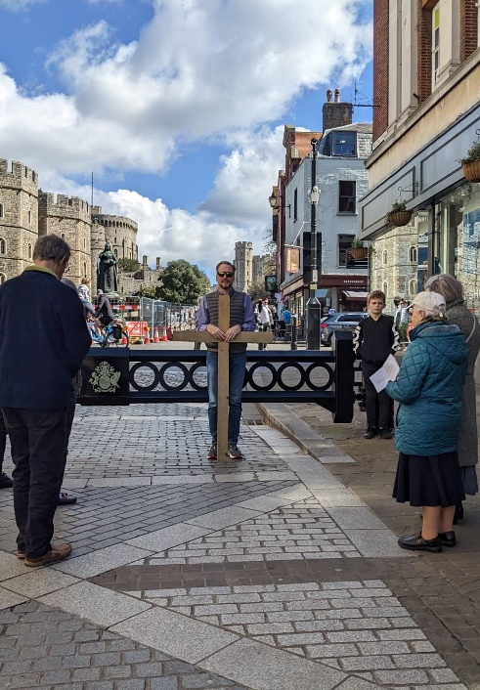
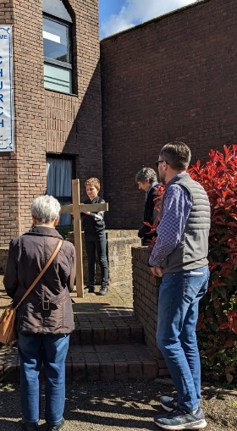
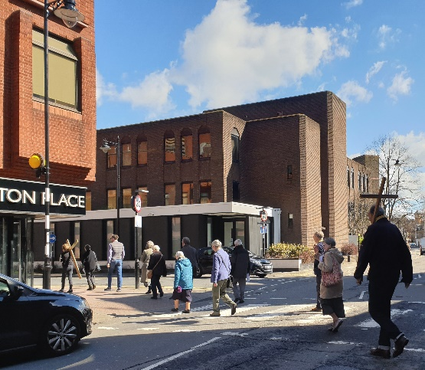
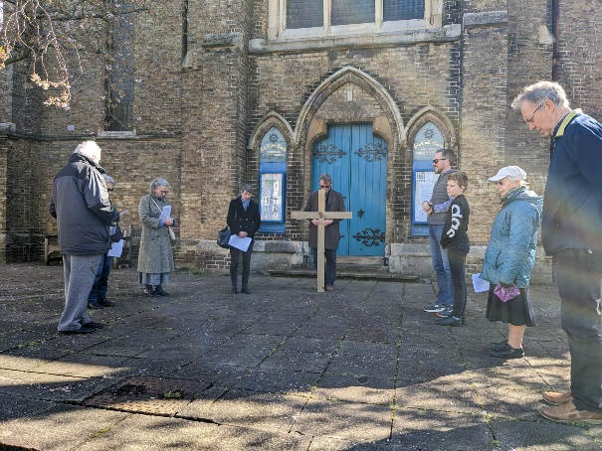
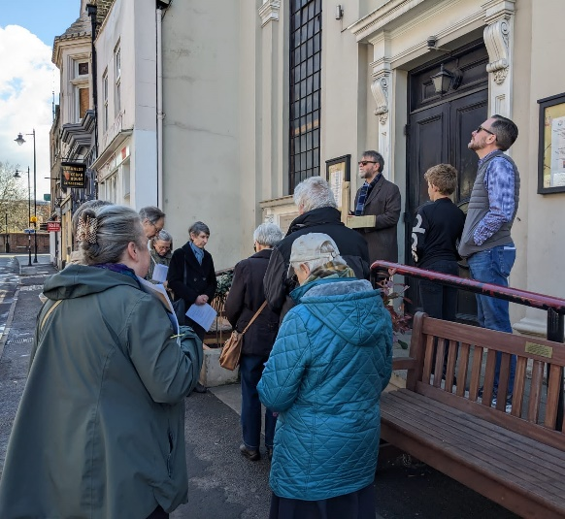
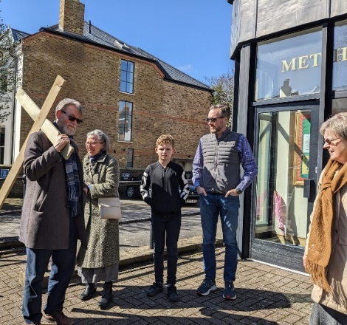
This year, Windsor's Good Friday Witness organised by Churches Together in Windsor took the form of a "Walk of Witness" through the town centre, allowing individuals to focus on the impact of Jesus' life, ministry and final hours before his crucifixion. Reflecting some of the ecumenical breadth of local worship, the cross-led procession began at Windsor Methodist Church and continued on to several other churches, where participants stopping briefly at each for a moment of silent prayer: St. Edward the Confessor RC Church; Holy Trinity Garrison Church; Windsor Baptist Church; Christ Church URC and Windsor Fellowship Church; and passing near St. George's Chapel, Windsor Castle, before finishing at Windsor Parish Church of St. John the Baptist. The Witness concluded with "Were You There" and an ecumenical selection of prayers before participants quietly dispersed.

A Christ Church URC member observed, "We much enjoyed the Walk of Witness. The leaders and cross bearers gave just the right impression... I think the Witness was well respected. Wording on the sheet and the spoken prayers were just right. Thank you for organising it."

CHURCHES TOGETHER IN WINDSOR
THY KINGDOM COME / PRAYER FOR CHRISTIAN UNITY, 18th – 28th MAY 2023
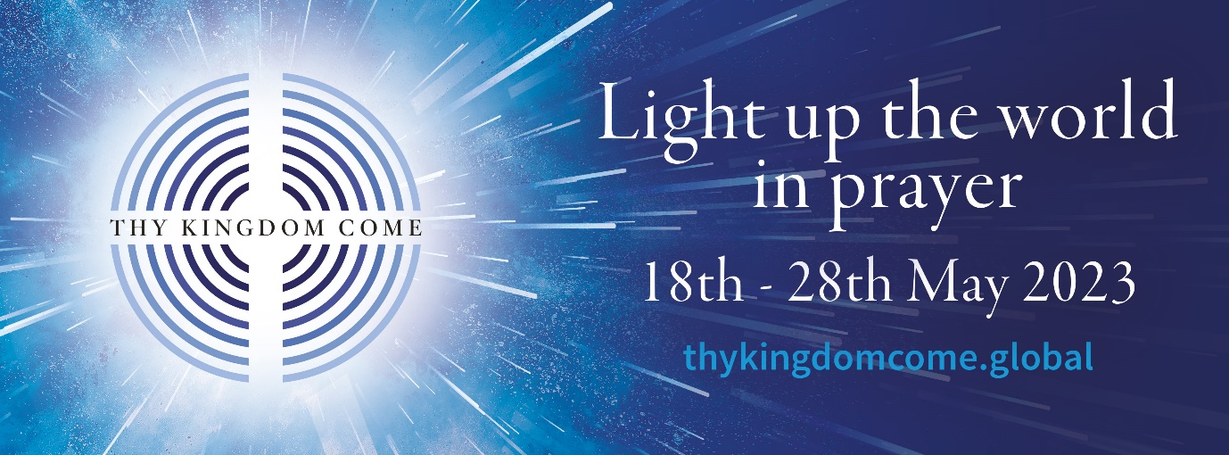
Thy Kingdom Come is a global prayer movement that invites Christians around the world to pray for more people to come to know Jesus. What started in 2016 as an invitation from the Archbishops of Canterbury and York to the Church of England has grown into an international and ecumenical call to prayer.
Experience Pentecost Stations for Thy Kingdom Come (TKC)
Six stations are set up around the churches to provide an interactive multi-sensory way to engage imaginatively with the events surrounding Pentecost.
1. Waiting – For the Holy Spirit to come - St Edwards
2. Receiving – With the Holy Spirit Came - Windsor Methodist (Cornerstone Chapel)
3. Telling – After the Holy Spirit came, the believers began to tell others - St Andrews
4. Doing – After the Holy Spirit came, they were bold enough to take action
5. Sharing – After the Holy Spirit came, they began to work together - Dedworth Green Baptist Church (displayed in the front window of the entrance area)
6. Growing – After the Holy Spirit came, the Church began to grow- inside Windsor Parish Church.

During these 11 days churches in Windsor are offering various opportunities
for us to come together to pray.
During these times, and at any other time you are able to, please pray for an outpouring of God’s Holy Spirit upon our churches and communities.

Date | Time | Venue | Notes
Daily, 18th – 27th May 2023 | 5pm | Zoom (hosted by St Andrews) | Zoom prayer (contact St Andrews for link)
Thursday 18th May 2023 | 9.30am  12 noon  6pm  7.30pm | St Edwards Church  St Andrews Church  St Edwards Church  Holy Trinity Church | Morning prayer  Service of the Word for Ascension  Evening prayer  Sung Eucharist for Ascension Day
Friday 19th May | 9am | Holy Trinity Church | Morning Prayer
Saturday 20th May
Sunday 21st May | 5.30pm | All Saints’, Frances Road | Choral Evensong with St Andrew’s
Monday 22nd May | 9am | All Saints, Frances Road | Morning Prayer
Tuesday 23rd May | 9.45am–12.15pm | Dedworth Green Baptist Church, Smiths Lane | ‘The WellSpring’ – a safe place where it’s okay not to be okay – pauses for prayer at 10am, 11am and 12 noon
 | 6pm | St Edwards Church | Evening prayer
Wednesday 24th May | 9am  9.30am  11am  12 noon  1.00 – 1.30pm | St Stephen & St Agnes Church  St Edwards Church  Holy Trinity Church  St Andrews Church  Windsor Methodist Church | Morning Prayer  Morning prayer  Holy Communion  ‘Lunch and more’  Prayers in the Cornerstone Chapel
Thursday 25th May | 9.30am  7-8pm | St Edwards Church  Kerith Church | Morning prayer  Prayers
Friday 26th May | 4pm | All Saints’ Frances Road | Messy Church for Pentecost
Saturday 27th May
Sunday 28th May | 10am  5pm | St Stephen & St Agnes  Windsor Methodist Church | Sung Eucharist for Pentecost  Joint Taize service for Pentecost
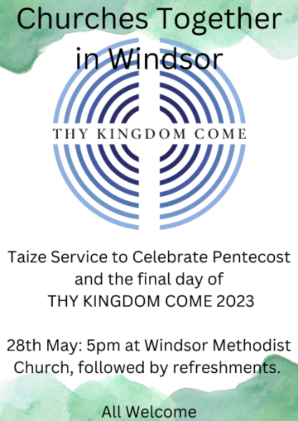
‘First of all, then, I urge that supplications, prayers, intercessions, and thanksgivings be made for everyone.’
1 Timothy 2.1

For more details of Thy Kingdom Come 2023, and to sign up for daily prayer videos during the above dates, visit https://www.thykingdomcome.global/lightuptheworld

Christian Aid Week:
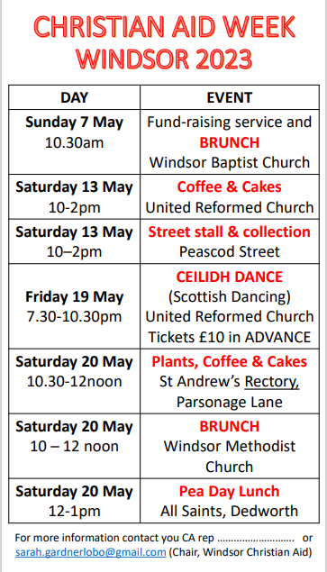
This year, Christian Aid Week runs from 14-20 May and our fund-raising activities focus on Malawi where Christian Aid has worked for 20 years. Working with local partners, Christian Aid is seeking to empower vulnerable communities in Malawi to find practical and sustainable ways out of poverty. This work includes training to equip these communities with skills to: - grow crops that are resilient to the climate crisis, to restore soil fertility, to increase harvests, to enhance their business skills and to form cooperatives to earn more money for their crops.
Here in Windsor, we are seeking to draw attention to the plight of these vulnerable communities in Malawi and the challenges they face from climate change; and to raise funds to support them. To help us in this work, we invite members of all the Windsor churches and the wider community to join us at one or more of the events:
Fund-raising service and BRUNCH on Sunday 7 May, 10.30 at Windsor Baptist Church
Coffee & Cakes on Saturday 13 May, 10.00am–2pm at United Reformed Church, William Street, or visit our Stall in Peascod St 10-2pm.
On Friday 19 May, we are holding a CEILIDH (Scottish Dancing) at United Reformed Church (URC) William Street (Tickets need to be purchased IN ADVANCE AS SOON AS POSSIBLE TO AVOID DISAPPOINTMENT! from ruth_norris@yahoo.com).
On Saturday 20 May, enjoy our Plant Sale & Coffee Morning at St Andrews’ Rectory, Parsonage Lane, before moving on to Brunch at Windsor Methodist Church and Pea Day Lunch at All Saints, Dedworth.
Further details are available from sarah.gardnerlobo@gmail.com
Thank you,
Sarah Gardner (Chair, Windsor Christian Aid)

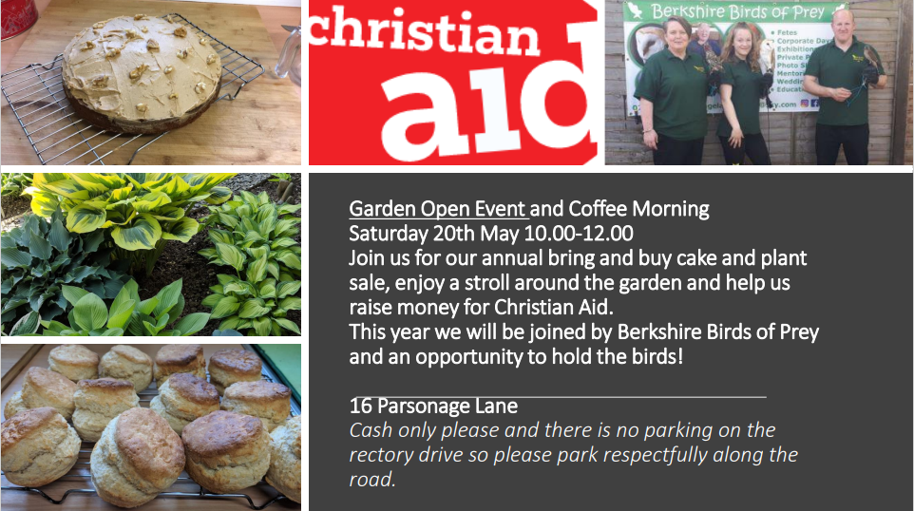

Save the date:
Rock the Rec: 1-2 July from 12 noon

News from the Churches:
From The Reverend Canon Sally Lodge
Team Rector, Benefice of New Windsor in the Diocese of Oxford:
Our big news is the installation of an amazing artwork in Windsor Parish Church which will be with us over the summer. Definitely worth popping in to take a look:
The Last Supper Sculpture by Peter Barnes Windsor Parish Church of St John the Baptist at High Street SL4 1LT
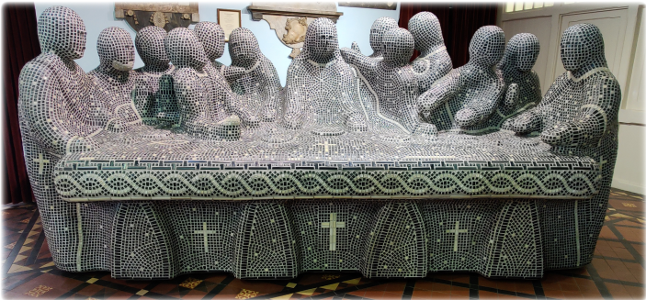
The Last Supper Sculpture was inspired by the painting by Leonardo da Vinci, and completed in December 2019. It is doing a pilgrimage of Cathedrals and Churches which began in Chester Cathedral on the 16th March 2020. The sculpture arrived in Windsor on 19 April 2023.
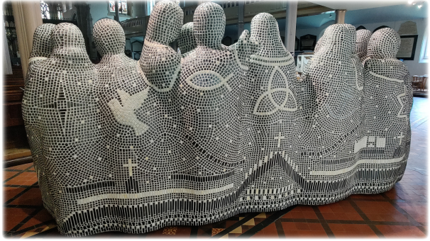

From Alison Mount
Senior steward, Windsor Methodist Church
On Saturday 20th May we will be holding a fundraising brunch in aid of Christian Aid.

During the 'Thy Kingdom Come' week leading up to Pentecost we are planning to re-open our cornerstone chapel which has been closed since the start of the pandemic and will place our Pentecost station there.

On Pentecost Sunday our morning service will involve various members of the congregation speaking in their own languages. In the afternoon we shall be hosting the CTW Taize service.

Looking ahead we are looking forward to our holiday club for 6-11 year olds which runs from 31st July to 4th August. This is now fully booked.

Looking further ahead we have a 'Petals and Praise' afternoon planned on Saturday 16th September; the weekend before our Harvest Festival celebrations. This will be a flower demonstration with hymn singing followed by a cream tea.

Ongoing activities:
Messy Church:
Dedworth Green Baptist Church: 2nd Sunday of the month, 3.00 - 5.30pm
St Andrews and All Saints Dedworth together at Clewer Green First School, quarterly

Methodist Church: Saturday afternoon (3.45 to 5.30 pm) in school holidays: includes craft activities, a short, fun act of worship and a meal. All are welcome. Children to be accompanied by an appropriate adult.

Methodist Church
We continue to hold a 'Teatime for the Soul' service on the first Sunday each month at 3pm. These increasingly popular services are aimed at those who find it difficult to come to church for 10-30am and are dementia friendly. They are about half an hour long with traditional, familiar hymns and a short message followed by tea and cakes downstairs in the hall. It has been a joy to see some of our older members who have not been back to church since the start of the pandemic. All are welcome, whether members of a church or none.

Sunday Evening Service, 6.30pm to 7.30pm. These are friendly, peaceful, spiritual Services including prayers, Bible readings and a Sermon. One each month is a ‘Café Style’ Service which often include interesting discussions. Our numbers of attendees vary, but normally about 12 of us. Any friends would be warmly welcomed!

The Methodist Church would also warmly welcome friends to Prayer Group meetings which are 6pm to 6.30pm on alternate Wednesdays in the Cornerstone Chapel, which is the door nearest the traffic lights. Dates are published on the website and in the weekly newsletter which is circulated electronically. If you would like to receive the Methodist newsletter, please email our Church Council Secretary at rosemarycracknell@btinternet.com Prayers are said for Christian growth in our Windsor Churches, our community, and anything else folks may be prompted to pray for.

Toddlers’ Group each Thursday (term time) welcomes all Toddlers with an appropriate adult from 09.15 to 11.15am at the Methodist Church.

Contact details for the churches are as follows:

CHURCH OF ENGLAND CHURCHES
Windsor Parish Church: Parish Church of St John the Baptist
The High Street, Windsor SL4 1LT
Telephone: 01753 862419
Minister: The Revd Canon Sally Lodge
E-mail: team@windsorchurches.org.uk
Website www.windsorparishchurch.org.uk
Services: Eucharist: SUNDAY: 10.00am for one hour (rotates between St Stephen & St Agnes; Holy Trinity; All Saints' and Windsor Parish Church)
All Saints’ Church
Frances Road, Windsor, SL4 1HU
Telephone: 01753 862419
Minister: The Revd Sally Lodge
E-mail: team@windsorchurches.org.uk; windsor.rector@ gmail.com
Website www.allsaintswindsor.org.uk
Services Eucharist: SUNDAY: 10.00am for one hour (rotates between St Stephen & St Agnes; Holy Trinity; All Saints' and Windsor Parish Church)
Sunday Xtra: Short, informal, contemporary, all age worship: 2nd and 4th SUNDAY 10.00am

Holy Trinity (Parish and Garrison Church),
Claremont Road & Trinity Place, Windsor, SL4 3AX
Telephone 01753 862419
Minister: The Revd Canon Sally Lodge
email holytrinitychurchwindsor@gmail.com
Website holytrinitywindsor.org.uk
Services: Eucharist: SUNDAY: 10.00am for one hour (rotates between St Stephen & St Agnes; Holy Trinity; All Saints' and Windsor Parish Church)

St Stephen & St Agnes, Clewer
Vansittart Road, Windsor, SL4 5EA
Telephone: 01753 862419
Minister: The Revd Canon Sally Lodge
E-mail: team@windsorchurches.org.uk
Website: www.ststephenwindsor.org.uk
Services: Eucharist: SUNDAY: 10.00am for one hour (rotates between St Stephen & St Agnes; Holy Trinity; All Saints' and Windsor Parish Church)

All Saints’ Church
Dedworth Road, Windsor, SL4 4JW
Telephone: 01753 841710
Minister: Revd. Paul Walker
E-mail: via website contact us page (http://allsaintschurchdedworth.com/contact/)
Website http://www.allsaintschurchdedworth.com/
Services: SUNDAY: 9.15 am – Traditional Service with Communion; 11.00am – Family Service
St Andrew’s Clewer,
Mill Lane, Windsor, SL4 5JH
Telephone: St Andrews Rectory 01753 852334
Minister: Revd. Rosie Webb
email: rector@clewerparish.org; office@clewerparish.org
Website: http://www.standrewsclewer.org
Services: Eucharist: SUNDAY: 10.30am

St George’s Chapel
Windsor Castle, Windsor, SL4 1NJ
Telephone: 01753 848888; recorded information line 01753 865538
Minister: Dean and Canons of Windsor
email chapteroffice@stgeorges-windsor.org
Website: http://www.stgeorges-windsor.org/
Services: WEEKDAYS: Holy Communion 8am; Evensong 5.15pm
SUNDAYS: Holy Communion 8.30am; Mattins and sermon 10.45am
Windsor Fellowship Church
Christ Church URC, William St, Windsor SL4 1BA Telephone: 01753 257868
Minister: Rev Tim Hiorns
E-mail: hello@windsorfellowship.com
Website: www.windsorfellowship.com
Services: SUNDAY: 4pm

NON-DENOMINATIONAL CHRISTIAN CHURCH
Kings Church International
Office: King's House, 77a Frances Road, Windsor, SL4 3AQ
Telephone: 01753 832444
Ministers: Pastors Wes & Adriana Richards
E-mail: hello@kcionline.org
Website: kcionline.org
Services: SUNDAY: service 10am online THURSDAY evening weekly prayer meetings online

KERITH COMMUNITY CHURCH
Unit 3B, Fairacres Industrial Estate,
Dedworth Rd, Windsor SL4 4LE
Telephone: +44 (0) 1344 862699
Minister: Leon Johnson
E-mail: info@kerith.church, leon.johnson@kerith.church
Website: https://kerith.church/
Service: SUNDAY 10am

BAPTIST CHURCHES
Dedworth Green Baptist Church,
Smiths Lane, Windsor, SL4 5PE
Telephone: 01753-832002
Minister: Revd. Matthew Scott
E-mail: minister@dgbc.org.uk, secretary@dgbc.org.uk
Website: http://www.dgbc.org.uk/
Services: SUNDAY: 10.30am

Windsor Baptist Church,
Victoria Street, Windsor, SL4 1EH
Telephone: 07971 298158
Minister: Revd. Kat Bracewell
Community Manager: Kate Saunders wbckate@gmail.com
E-mail windsorbaptists@yahoo.co.uk; kathryn.bracewell@yahoo.co.uk
Website https://windsorbaptistchurch.org.uk
Services: SUNDAY 10.30am

ROMAN CATHOLIC CHURCHES
St. Edward’s Church
44 Alma Road, Windsor, SL4 3HJ
Telephone: 01753 865163
Minister: Canon David Hopgood
E-mail: canondavid@catholicwindsor.org
Website: http://catholicwindsor.org/
Services: SATURDAY: Mass 6.00pm
SUNDAY: Mass: 11.00am.
TUESDAY: Mass: 6.30pm
WEDNESDAY: Mass: 10.00am
THURSDAY: Mass: 10.00am
FRIDAY: Mass: 12.00am (weekday service times may change due to funerals etc)

St Mark’s Church
Dedworth Road, Windsor, SL4 4JS
Telephone: 01753 865163
Minister: Canon David Hopgood
E-mail: canondavid@catholicwindsor.org
Website: http://catholicwindsor.org/
Services: SUNDAY: Mass 9.30am

UNITED REFORMED CHURCH
Christ Church
William Street, Windsor, SL4 1BA
Telephone: 01753 862007
Minister: Revd. Alan Wickens
E-mail: revawickens@gmail.com
Website http://www.windsorurc.org.uk/
Services: SUNDAY: 10.30am (also on zoom – see website for details)

METHODIST CHURCH
Alma Road, Windsor, SL4 3HH
Telephone: 01753 536357
Minister: Revd. Vicci Davidson
E-mail rev.vicci@mail.com
Website: http://www.windsormethodist.church/
Services: SUNDAY Morning service 10.30am
Evening service 6.30pm

