Churches Together in Windsor
Newsletter
Autumn 2022

Message from the Chair:
The community of the King of kings
The events surrounding the Queen’s death and funeral this month have left their imprint on our memories, as we have watched dawn to dusk TV coverage and, in some ways, participated in what for most of us was the first time we had experienced a change of monarch.
Whether you are an ardent royalist or a fervent republican, it is good to give God thanks for the way that the Queen’s faith in Jesus Christ shaped her life and influenced our society for good – and we pray for King Charles III as he succeeds her.
Perhaps one of the most striking things to witness as people queued for hours on end to file past her coffin, or waited patiently on roadsides or on the Long Walk for her funeral procession to pass, was the number of times people mentioned that they felt a sense of community in the occasion. New friendships were being built amongst the crowds, and practical support was being given, received and deeply appreciated. As some put it, “Everyone’s very friendly, and we’re all here for the same thing, which is to honour the Queen. We’ve met people and we shared stories.” In fact, that’s not a bad description of the nature of community.
That experience serves as a useful reminder that a significant part of the role of the Church is to model community. One of my recent preachers changed the quote slightly to read “We’re here for the same thing…to honour the King of kings… we’ve met people… and we’ve shared stories,” and observed that that sounds a bit like… church! Jesus himself highlighted the importance of community amongst his followers with the words, “Your love for one another will prove to the world that you are my disciples.” (John 13:35, NLT)
So, as this newsletter shares news and stories about what is going on in the various congregations of the Church in Windsor, may our love for each other – within our congregations, between our congregations and for our neighbours – speak to our community as a whole of the love that Jesus, the King of kings, has for everyone.

Rev Matthew Scott, Chair, Churches Together in Windsor

For your diary:
Sarah Gardner (Chair of Christian Aid) writes:
Autumn events at Windsor Christian Aid
As I write this, the nation is preparing for the State Funeral of Queen Elizabeth II. In remembering Queen Elizabeth, Christian Aid wrote:
Queen Elizabeth II dedicated her life to the UK and Commonwealth. We will always be grateful for her truly remarkable service.
Queen Elizabeth leaves behind a powerful legacy, not least in championing friendship between people of all faiths and none, and the diverse peoples of the world. She always promoted development of the person, communities, structures, and social wellbeing. https://www.christianaid.org.uk/news/in-memory-of-queen-elizabeth
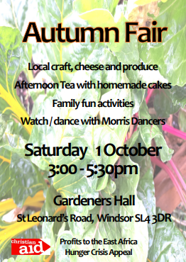
Many of the Commonwealth nations are facing significant challenges from climate change. At the present time, the floods in Pakistan and the Hunger Crisis following drought in East Africa are in the news. In response to these specific emergencies, Windsor Christian Aid is holding an Autumn Fair at Gardeners Hall on 1 October from 3.00 – 5.30pm. The Fair brings together a variety of local craft, cheese and produce stalls, family fun activities and plenty of tea and homemade cake. Do come and join us and help us raise a goodly sum for the DEC (Disasters Emergency Committee) Appeal for Pakistan and Christian Aid’s East Africa Hunger Crisis Appeal.

We thank all those churches who have supported us throughout this year and especially during Christian Aid Week in May. With your support, we have already raised over £12,000 for the work of Christian Aid since January 2022.
Our final event for the year will be the Christian Aid Advent Service which we are planning to hold in the afternoon of Sunday 4 December 2022, venue to be decided. We hope that many of our Christian Aid friends and supporters will be able to join us for the Service and for refreshments afterwards. For more information, please contact Sarah Gardner, Chair, Windsor Christian Aid Group, sarah.gardnerlobo@gmail.com
As we continue with the work of Christian Aid’s mission “to create a world where everyone can live a full life, free from poverty”, we remember Queen Elizabeth’s dedication and hard work in bringing together peoples of diverse nations. We pray that her words and actions will inspire us to renewed action to end poverty and social injustice.

A prayer from Christian Aid in memory of Queen Elizabeth:
Faithful God, we remember with thanksgiving and gratitude, the life and service of Queen Elizabeth.
We have been inspired by her dedication and faith, her commitment to the welfare of the United Kingdom and her lifelong devotion to the peoples of the Commonwealth.
As we pray for her family and with the nations, may the integrity of her public service, her concern for the common good and her steadfast commitment to good governance inspire all those in public office, in the UK and Commonwealth and across the world, to uphold the rights of all peoples in the pursuit of justice and the interests of peace.
Amen

From Holy Trinity Parish & Garrison Church:

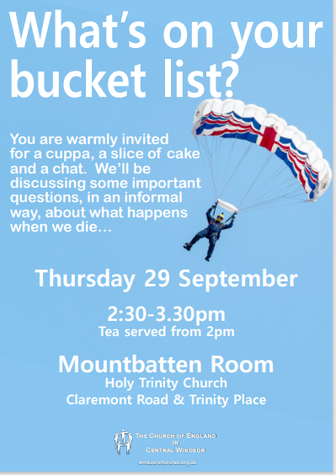

Alison Mount sends out the following:
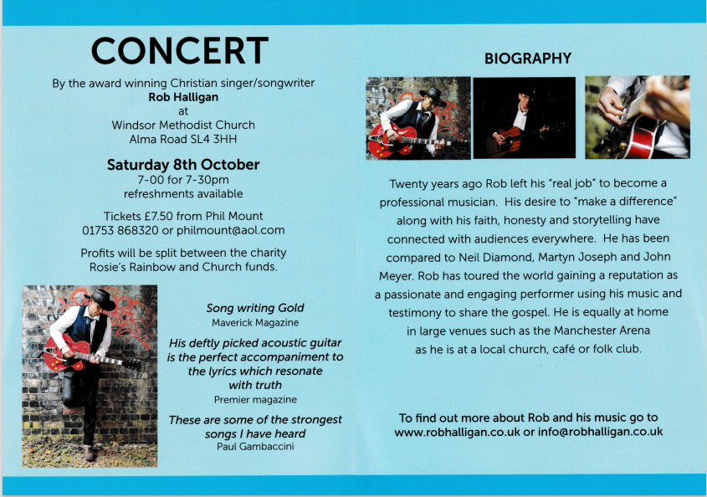
Windsor Methodist Church invites everyone to the award-winning Christian singer/ songwriter Rob Halligan Concert, 7 for 7.30 pm on Saturday 8 October at our Church in Alma Road, Windsor SL4 3HH.

Tickets are £7.50 and available from philmount@aol.com . Refreshments will be available and all profits will go to the charity ‘Rosie’s Rainbow’ and Windsor Methodist Church funds.

From Holy Trinity Parish & Garrison Church:
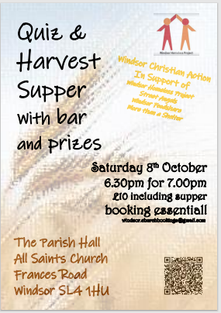
John Halsey sends out the following:
'Big Weekend' at All Saints' Church, Frances Road 28th-30th OCTOBER
All Saints' Church celebrates its patronal festival with a 'Big Weekend' including Messy Church, Open Afternoon, Patronal Festival Eucharist and a concert by local group 'Box & Fir'.
Friday 4pm Messy Church
Bible stories, fun activities and a meal for young families
Saturday 2pm Open Afternoon
3pm A 20-minute talk by Revd Dr Jeremy Hurst on Bishop Samuel Wilberforce who blessed the church's foundation stone in 1863 and dedicated the finished building in 1864.
Followed by a guided tour.
Admission is free and tea and cake will be served.
Sunday 10am All Saints’ Day Sung Eucharist with children’s activities
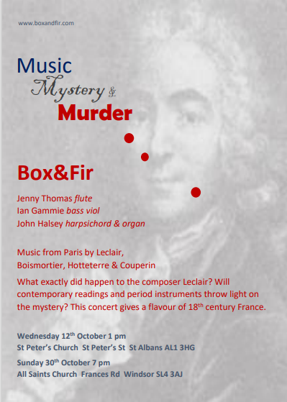
Sunday 7pm Concert in aid of Lighting Appeal
18th century music for organ, harpsichord, flute and bass viol: £10
The Sunday evening concert is given by Frances Road resident Jenny Thomas (flute) together with the church's organist John Halsey and Ian Gammie (bass viol). Proceeds from the concert go to the church's £60,000 lighting appeal. When finished, the lighting will be more energy efficient as well as brighter! It will also illuminate some of the church's stained-glass windows, so that they can be appreciated by walkers-by as well as by those inside the church. Tickets are £10 at the door. Or for BACS payment details and to receive a concert programme in advance, email jphalsey@btinternet.com.
ALL WELCOME. REFRESHMENTS SERVED AT ALL EVENTS

SAVE THE DATES!
Churches Together in Windsor AGM Thursday 17th November at the Methodist Church 7.45 for 8pm start.
After a short business meeting, there will be a short concert featuring the Signature a capella group, which rehearses each week at St Edward’s church – do come along and hear them!

Carols on the Hill: Friday 9th December: 6.30pm at the statue of Queen Victoria.
The charities we will be supporting this year are the Baby Bank and Windsor Christian Action.

Rev. Rosie send out the following:
St Andrews Faith and Families Programme
Harvest Festival- 2nd October at 10.30am. Please bring items as requested by the Windsor Food Share
Pet Service- 9th October at 3pm. In honour of St Francis, come and join us for a colourful and noisy pet service! Please bring your well-behaved pets and let’s give thanks to God for the joy our pets bring us!
Wild Church- our new monthly Wild Church begins on 16th October and 20th November at 3pm in Clewer Pk. Dress for the weather and join us as we explore and discover a sense of awe and wonder of creation. We are all called to care for creation, together we will learn the task of treading more carefully and gently on it. The gospels are full of stories of the growth of seeds, thistles and lilies and fruitful trees, Jesus noticed and so must we.
Remembering:
Light up for Loved Ones- Join us as we remember All Souls and help us light up as many graves as we can in the churchyard 30th October 5pm
Remembrance Day- 11 Nov at the War Memorial in the Pirate Park, 11am. A short time to reflect and pray together.
Remembrance Sunday - 13th November 10.45am at the War Memorial in the Pirate Park, Dedworth Rd. Join us with the Uniformed Organisations for this annual community event, to lay wreaths and to remember those who died in the World Wars and subsequent wars.
Peal for St Andrew- our bell ringers and a group of visiting ringers will be ringing a full peal in honour of St Andrew on Sunday the 27th November. This is no mean feat and will take about 3 hours! We hope you will stop and listen as you go about your Sunday.

St Andrews Day- our patronal Eucharist will be held on 30th November at midday, at St Andrews.

Dedworth and Clewer Community Christmas Fair at the Pirate Park on 27th November. Come along and visit the stalls and join us for our Advent Carol service at 4pm followed by the switching on of the park Christmas lights. Help us to share the message of Advent and Christmas in the community and join in singing!!

St Andrews Christmas Fair - Saturday 3rd December 11am- 2pm. Visit the stalls, enjoy a cuppa and chat, do some shopping and help raise funds for the 'oldest building in Windsor'.

Clewminations! Light Up for Christmas- lighting up St Andrews churchyard has become a new tradition! Many of the churchyard trees along the path were decorated last year. This year we invite the community again to get involved, to raise awareness of our community, to share the message of Christmas and to bring some sparkle and shine for everyone to enjoy. If you would like to decorate a tree in honour of your organisation within Clewer, then please contact Revd Rosie- rector@clewerparish.org.

Ongoing activities:
Messy Church:
Dedworth Green Baptist Church: 2nd Sunday of the month, 3.00 - 5.30pm
St Andrews and All Saints Dedworth together at Clewer Green First School, quarterly

Methodist Church: Saturday afternoon (3.45 to 5.30 pm) in school holidays: includes craft activities, a short, fun act of worship and a meal. All are welcome. Children to be accompanied by an appropriate adult.

Methodist Church
We continue to hold a 'Teatime for the Soul' service on the first Sunday each month at 3pm. These increasingly popular services are aimed at those who find it difficult to come to church for 10-30am and are dementia friendly. They are about half an hour long with traditional, familiar hymns and a short message followed by tea and cakes downstairs in the hall. It has been a joy to see some of our older members who have not been back to church since the start of the pandemic. All are welcome, whether members of a church or none.

Sunday Evening Service, 6.30pm to 7.30pm. These are friendly, peaceful, spiritual Services including prayers, Bible readings and a Sermon. One each month is a ‘Café Style’ Service which often include interesting discussions. Our numbers of attendees vary, but normally about 12 of us. Any friends would be warmly welcomed!

The Methodist Church would also warmly welcome friends to Prayer Group meetings which are 6pm to 6.30pm on alternate Wednesdays in the Cornerstone Chapel, which is the door nearest the traffic lights. Dates are published on the website and in the weekly newsletter which is circulated electronically. If you would like to receive the Methodist newsletter, please email our Church Council Secretary at rosemarycracknell@btinternet.com Prayers are said for Christian growth in our Windsor Churches, our community, and anything else folks may be prompted to pray for.

Toddlers’ Group each Thursday (term time) welcomes all Toddlers with an appropriate adult from 09.15 to 11.15am at the Methodist Church.

Contact details for the churches are as follows:

CHURCH OF ENGLAND CHURCHES
Windsor Parish Church: Parish Church of St John the Baptist
The High Street, Windsor SL4 1LT
Telephone: 01753 862419
Minister: The Revd Canon Sally Lodge
E-mail: team@windsorchurches.org.uk
Website www.windsorparishchurch.org.uk
Services: Eucharist: SUNDAY: 10.00am for one hour (rotates between St Stephen & St Agnes; Holy Trinity; All Saints' and Windsor Parish Church)

All Saints’ Church
Frances Road, Windsor, SL4 1HU
Telephone: 01753 862419
Minister: The Revd Sally Lodge
E-mail: team@windsorchurches.org.uk; windsor.rector@ gmail.com
Website www.allsaintswindsor.org.uk
Services Eucharist: SUNDAY: 10.00am for one hour (rotates between St Stephen & St Agnes; Holy Trinity; All Saints' and Windsor Parish Church)
Sunday Xtra: Short, informal, contemporary, all age worship: 2nd and 4th SUNDAY 10.00am

Holy Trinity (Parish and Garrison Church),
Claremont Road & Trinity Place, Windsor, SL4 3AX
Telephone 01753 862419
Minister: The Revd Canon Sally Lodge
email holytrinitychurchwindsor@gmail.com
Website holytrinitywindsor.org.uk
Services: Eucharist: SUNDAY: 10.00am for one hour (rotates between St Stephen & St Agnes; Holy Trinity; All Saints' and Windsor Parish Church)

St Stephen & St Agnes, Clewer
Vansittart Road, Windsor, SL4 5EA
Telephone: 01753 862419
Minister: The Revd Canon Sally Lodge
E-mail: team@windsorchurches.org.uk
Website: www.ststephenwindsor.org.uk
Services: Eucharist: SUNDAY: 10.00am for one hour (rotates between St Stephen & St Agnes; Holy Trinity; All Saints' and Windsor Parish Church)

All Saints’ Church
Dedworth Road, Windsor, SL4 4JW
Telephone: 01753 841710
Minister: Revd. Paul Walker
E-mail: via website contact us page (http://allsaintschurchdedworth.com/contact/)
Website http://www.allsaintschurchdedworth.com/
Services: SUNDAY: 9.15 am – Traditional Service with Communion; 11.00am – Family Service

St Andrew’s Clewer,
Mill Lane, Windsor, SL4 5JH
Telephone: 01753864169 (Church Office -staffed part-time)
Minister: Revd. Rosie Webb
email: rector@clewerparish.org; office@clewerparish.org
Website: http://www.standrewsclewer.org
Services: Eucharist: SUNDAY: 10.30am

St George’s Chapel
Windsor Castle, Windsor, SL4 1NJ
Telephone: 01753 848888; recorded information line 01753 865538
Minister: Dean and Canons of Windsor
email chapteroffice@stgeorges-windsor.org
Website: http://www.stgeorges-windsor.org/
Services: WEEKDAYS: Holy Communion 8am; Evensong 5.15pm
SUNDAYS: Holy Communion 8.30am; Mattins and sermon 10.45am

Windsor Fellowship Church
Christ Church URC, William St, Windsor SL4 1BA Telephone: 01753 257868
Minister: Rev Tim Hiorns
E-mail: hello@windsorfellowship.com
Website: www.windsorfellowship.com
Services: SUNDAY: 4pm

NON-DENOMINATIONAL CHRISTIAN CHURCH
Kings Church International
Office: King's House, 77a Frances Road, Windsor, SL4 3AQ
Telephone: 01753 832444
Ministers: Pastors Wes & Adriana Richards
E-mail: hello@kcionline.org
Website: kcionline.org
Services: SUNDAY: service 10am online THURSDAY evening weekly prayer meetings online

KERITH COMMUNITY CHURCH
Unit 3B, Fairacres Industrial Estate,
Dedworth Rd, Windsor SL4 4LE
Telephone: +44 (0) 1344 862699
Minister: Leon Johnson
E-mail: info@kerith.church, leon.johnson@kerith.church
Website: https://kerith.church/
Service: SUNDAY 10am

BAPTIST CHURCHES
Dedworth Green Baptist Church,
Smiths Lane, Windsor, SL4 5PE
Telephone: 01753-832002
Minister: Revd. Matthew Scott
E-mail: minister@dgbc.org.uk, secretary@dgbc.org.uk
Website: http://www.dgbc.org.uk/
Services: SUNDAY: 10.30am

Windsor Baptist Church,
Victoria Street, Windsor, SL4 1EH
Telephone: 07971 298158
Minister: Revd. Kat Bracewell
Community Manager: Kate Saunders wbckate@gmail.com
E-mail windsorbaptists@yahoo.co.uk; kathryn.bracewell@yahoo.co.uk
Website https://windsorbaptistchurch.org.uk
Services: SUNDAY 10.30am

ROMAN CATHOLIC CHURCHES
St. Edward’s Church
44 Alma Road, Windsor, SL4 3HJ
Telephone: 01753 865163
Minister: Canon David Hopgood
E-mail: canondavid@catholicwindsor.org
Website: http://catholicwindsor.org/
Services: SATURDAY: Mass 6.00pm
SUNDAY: Mass: 11.00am.
TUESDAY: Mass: 6.30pm
WEDNESDAY: Mass: 10.00am
THURSDAY: Mass: 10.00am
FRIDAY: Mass: 12.00am (weekday service times may change due to funerals etc)

St Mark’s Church
Dedworth Road, Windsor, SL4 4JS
Telephone: 01753 865163
Minister: Canon David Hopgood
E-mail: canondavid@catholicwindsor.org
Website: http://catholicwindsor.org/
Services: SUNDAY: Mass 9.30am

UNITED REFORMED CHURCH
Christ Church
William Street, Windsor, SL4 1BA
Telephone: 01753 862007
Minister: Revd. Alan Wickens
E-mail: revawickens@gmail.com
Website http://www.windsorurc.org.uk/
Services: SUNDAY: 10.30am (also on zoom – see website for details)

METHODIST CHURCH
Alma Road, Windsor, SL4 3HH
Telephone: 01753 536357
Minister: Revd. Vicci Davidson
E-mail rev.vicci@mail.com
Website: http://www.windsormethodist.church/
Services: SUNDAY Morning service 10.30am
Evening service 6.30pm

