Churches Together in Windsor
Newsletter
Autumn 2021

Message from the Chair:

‘Accept one another… just as Christ accepted you’
The recent Olympic and Paralympic Games events had me wondering… is God’s Church an Olympian or a Paralympian movement? Often our first instinct is that we need to attract the wealthiest, most gifted, most attractive people into our congregations to strengthen and equip us for ministry and mission – people who we might regard as ‘Olympians’ by the world’s standards. Yet we know that the Gospel of Jesus invariably points us in a counter-cultural direction. The opening statement of Jesus’ ministry was that he came to ‘…proclaim good news to the poor… freedom for the prisoners [and the oppressed] … and recovery of sight for the blind.’ (Luke 4:18). He went on to recruit ‘tax collectors and sinners’ to follow him and to establish the Church.
The apostle Paul realised the significance of this, when he claimed that his strength lay, not in his natural abilities, but in God’s grace at work through his weaknesses, as he concluded ‘when I am weak, then I am strong’. (2 Corinthians 12:1-10). If he were around today, I therefore imagine he would liken the Church to the Paralympian movement – full of people who by God’s grace excel despite their limitations. The implication is that the more we realise our weakness and our need for God, the stronger the Church becomes.
No wonder Paul elsewhere encourages this assorted bunch of flawed individuals to ‘Accept one another… just as Christ accepted you, in order to bring praise to God.’ (Romans 15:7) We are works in progress, not the finished product, and so both within our congregations and between our congregations, God calls us to accept one another ‘warts and all’, and to take things from there. It won’t be easy – but in doing so we show God’s love to a broken world, and so hold out the hope that God’s love is for everyone, especially those most in need. That’s why we were so thrilled recently at the success of the first ‘Windsor Church Fest’ initiative, where our churches worked together to show God’s love to our community. Read on to find out more about what’s been happening and what’s coming up in our life together…
Rev Matthew Scott, Chair, Churches Together in Windsor

News:
Church Fest
A BIG thank you to everyone who put in lots of effort and encouragement in support for our CTW Church Fest on Bank Holiday Sunday. The day went really well. Lots of fun and games, activities and crafts and even some water shooting!

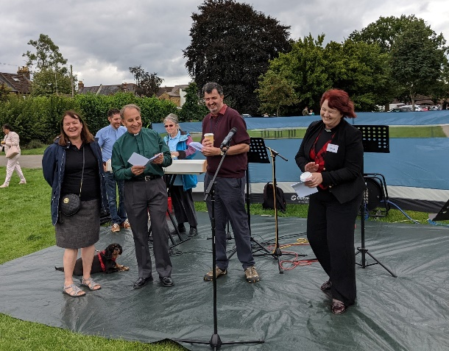
The day was complemented by live music contributions from St Andrews, Windsor Methodist and ASD. A particular bit of fun was an aerobics session to music from LZ7, good job we had a first aider on hand! 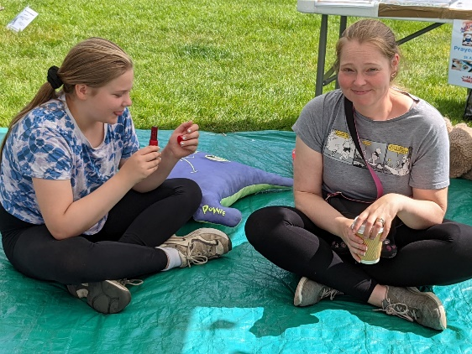

The feedback has been really positive and it seems there might be some enthusiasm to hold this again. It was lovely to hear faith stories and share our faith within our community in such a public place and share a Welcome to Revd Paul from ASD, it was great to meet you.
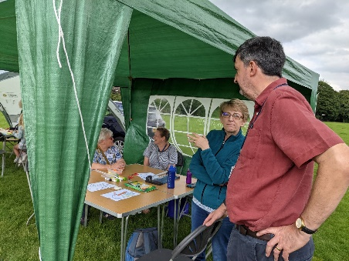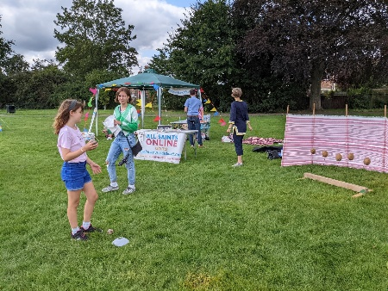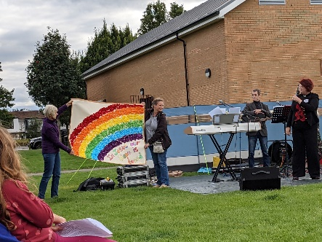
Thank you again to all those on the fest team for helping to bring the vision alive.
With prayers and thanksgiving
Revd Rosie

New minister for Windsor Fellowship Church
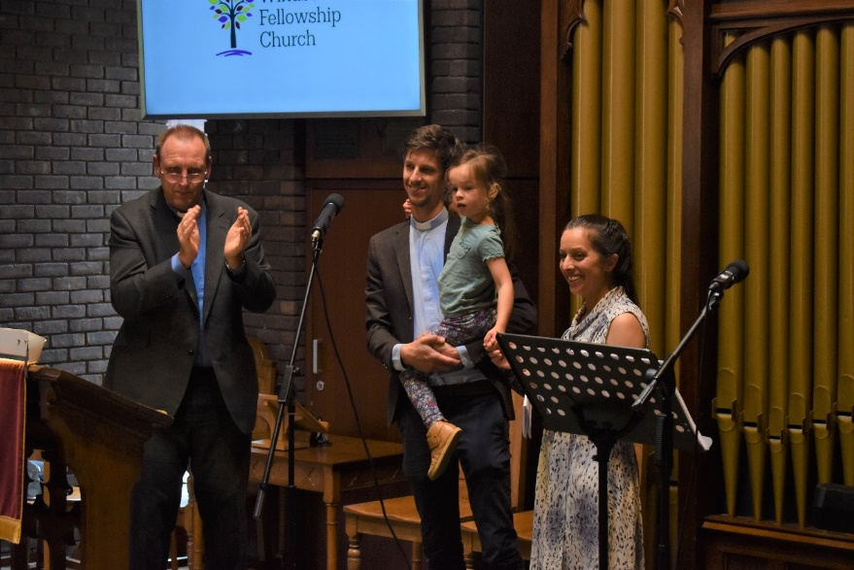
On Sunday 5th September, Rev Tim Hiorns was commissioned as the new minister for Windsor Fellowship Church. Tim was previously curate at All Saints, Crowborough and comes to Windsor with his wife Lucy and daughters Avani and Elsie. We are so grateful to God for Tim’s appointment and excited for the future as he leads the church in this new chapter of its life.
It was a pleasure to have other local ministers with us at the commissioning service and we look forward to working together as we share the Gospel and serve our community in Windsor. We are also very thankful to the URC for their generosity in enabling Windsor Fellowship to meet in their building on William St.

Rev’d Vicci Davidson, being very musically talented, along with her family, has formed “ALOUD!!” This involves young people learning to play the ukulele and singing, it is well attended and great fun. Also, the Methodist Church now have a choir and band all under the professional leadership of Vicci.

For your diary:
September:
Sunday 19th September: 10.30am Service at the Methodist Church to remember those members & friends who have died since the start of the pandemic. To be followed by a Faith lunch.

The Windsor Christian Aid Group is organising a Taize-style ecumenical Prayer Service for Climate Justice, to be held at St Edwards Catholic Church, Alma Road, Windsor SL4 3HJ at 4 pm on Sunday 19 September. Many churches in Windsor are focussing on issues around climate change. We hope this will be an important opportunity when Christians across Windsor come together to pray about issues relating to climate change, climate justice, and in particular to pray for world leaders and the UK government leading up to COP26 in Glasgow in November. This will be an ecumenical service of prayer, reflection & song to encourage us all to take action on climate change and to act justly. The service will be followed by refreshments in the Parish Hall at 5pm.
2021 is a significant year for Our Planet. In November, the UK hosts the UN Climate Summit (COP26), when world leaders will present their goals for halting the rise in global warming. To highlight the Summit and the issues that will be considered there, Windsor Christian Aid is setting up a ‘Creation in Crisis’ trail with 15 stations, around Windsor town centre for the weekend of 25-26 September. The trail will highlight key issues of the current global environmental crisis using artwork, factual summaries, reflections and suggested actions. The trail will be marked on a specially prepared map which people can use to locate each station. Our ambition for the Trail is to raise people’s awareness of the State of Our Planet, of how our behaviours can exacerbate or diminish this State and of the significance of COP26 for all our futures. We hope that the Trail will be fun and educational and will encourage people to act.
For more information on these two Christian Aid events, please contact tracytickle@hotmail.com or sarah.gardnerlobo@gmail.com

26th September is the anniversary of John Wesley first preaching in Windsor. At
6.30pm in the Methodist Church there will be a "Victorian Tent Mission Revival" service, commemorating one of John Wesley’s visits to Windsor. This will be a Cafe-style Service. You are encouraged to come in Victorian dress befitting the times.

The licensing of the new Priest in the New Windsor Team, The Reverend Richard Terrado-Reardon, will be on Wednesday 29th September at 7pm in St Stephen and St Agnes, Vansittart Road. The Archdeacon of Berkshire will take the service. All are welcome.

October:
2nd/3rd October Harvest weekend: Praise, worship, fish & chips, dancing...lots of fun & fellowship at the Methodist Church.

On Friday 15 October: Windsor Christian Action are holding their Homeless Project Sleep-Out. Donations can be made at: www.virginmoneygiving.com/fund/whpsleepout2021 If you want to sleep out yourself, contact: kimhlewis@hotmail.com
On 23 October at 2.30 pm there will be a Thanksgiving Service for the life of Dr John Long CVO at the Methodist Church. John was widely known in Windsor and all will be welcome.

November:
The Churches Together in Windsor Annual Assembly will be held at 7.45pm on Thursday 18 November at the Methodist Church. All are welcome to attend. The short business meeting will be followed by a talk from Rev. Rosie on the Clewer 1816 Trust.
The Churches Together in Windsor aims and functions from the constitution are described as follows:
Our Lord Jesus Christ prayed for his disciples, and thus for the Church, in these words: “that all of them may be one, Father, just as You are one in Me and I am one in You. May they also be one in Us so that the world may believe that You have sent Me.” (John 17 vv 21-22) To help us answer that prayer, we recognise that we need to:
a. encourage the local churches to work together wherever and whenever possible;
b. worship and pray together;
c. learn more about the Christian faith together;
d. co-ordinate resources for Christian evangelism and service to the Windsor community as they arise;
e. keep each church informed of the work and developments in the churches of CTW;
f. promote and support the ecumenical movement.”
Churches Together in Windsor comprises member churches who – at the Annual Assembly – elect a Core Group, who hold four meetings a year, including planning the key events: Good Friday Witness, Thy Kingdom Come (around Pentecost) and Carols on the Hill.
The Core Group includes a Chair, Vice-Chair, Treasurer, Secretary and additional members (lay or clergy). We are seeking new members for the Core Group, in particular one new person to take on the role of Treasurer (there will be a handover from the current Treasurer), one person who would like to be involved in Carols on the Hill next year (who would shadow at meetings this year) and more lay members.
Nominations for anyone who would like to join the Core Group should be sent to jacobyvpatterson@gmail.com by 1 November please.

December:
Saturday 11th December: 11 am to 2 pm - Live Nativity event at the Methodist Church! All are welcome!

Carols on the Hill will be held on Friday 10th December at 6.15pm (band to play for 15 minutes, then service to start at 6.30pm) near the statue of Queen Victoria by the Castle.

Ongoing activities:
Messy Church:
Dedworth Green Baptist Church: 2nd Sunday of the month
St Andrews and All Saints Dedworth together at Clewer Green First School, quarterly, the next one on 10th October and then 12 December, 3pm

Methodist Church: Saturday afternoon (3.45 to 5.30 pm) in school holidays including Saturday 6 November: includes craft activities, a short, fun act of worship and a meal. All are welcome. Children to be accompanied by an appropriate adult.

Methodist Church Sunday Evening Service, 6.30pm to 7.30pm. These are friendly, peaceful, spiritual Services including prayers, Bible readings and a Sermon. One each month is a ‘Café Style’ Service which often include interesting discussions. Our numbers of attendees vary, but normally about 12 of us. Any friends would be warmly welcomed!

The Methodist Church would also warmly welcome friends to Prayer Group meetings which are 6pm to 6.30pm on alternate Wednesdays in the Cornerstone Chapel, which is the door nearest the traffic lights. Dates are published on the website and in the weekly newsletter which is circulated electronically. If you would like to receive the Methodist newsletter, please email our Church Council Secretary at rosemarycracknell@btinternet.com Prayers are said for Christian growth in our Windsor Churches, our community, and anything else folks may be prompted to pray for.

Toddlers’ Group each Thursday (term time) welcomes all Toddlers with an appropriate adult from 09.15 to 11.15am at the Methodist Church.

Windsor Carers Group:
The Carers Group meets on the 2nd Monday of the month from 10.30-11.30am at Dedworth Green Baptist Church, Smiths Lane. The group is largely for mutual support and to provide a ‘Time Out’ for carers. From time to time we have outside speakers on related topics. The group is open to anyone who is in a caring role, whatever the condition. Further information can be obtained from Carol Edwards caroledwards91@btinternet.com or Pat Targett pat.targett8@gmail.com

Report from Windsor Christian Action:
Some highlights across our four Projects

New premises update
The premises in Alma Road which WCA has secured as a base for all four of its projects has now been cleared out. We currently have a draft lease, and are hoping to secure the lease as soon as possible, so that work can begin on renovations.
RBWM have supplied us with a Project Manager, who has started work on the building requirements specification. When this is complete, it will enable us to obtain quotations, which are required for both budgeting purposes and to support grant applications. Once we have the agreed lease and quotations, we will be able to start fundraising. It will then be 'all hands on deck' to raise the £120,000-£150,000 which we estimate will be required to make the building fit for purpose.
We are so excited to have the prospect of a base for WCA. This will mean that our projects can work together more effectively to support vulnerable people in our community.

Rise in demand for Foodshare
There has been a rise in demand for the service offered by Foodshare. May thanks to all of the volunteers who have worked tirelessly alongside Maria, and put in many extra hours in recent months to keep everything going. Thank you to those at Kerith Church who have been involved, and also to the Windsor Lions, who are also a huge support. An average of 70 vouchers are currently given out each week.

Street Angels seeks funding for paramedic
Windsor Street Angels had to stop their patrols during lockdown. At this time, virtual training courses were held for volunteers. In the last few months, the patrols have gradually restarted, and the Hub at Windsor Baptist Church also opened again on 24th July. The aim is to acquire the support of a paramedic, when funding is found. There are currently 36 volunteers, with 7 new ones recently coming on board.

The Sleepout will be held outside at Windsor College on 15th October. Please save the date! More details soon.

Other Homeless Project news
Funding has been secured from Public Health England for a part time Drug and Alcohol support worker who will work with some of our guests who struggle the most. Congratulations to Carron Edgell, who has been appointed to the role, and is due to start later on in September.
The Saturday sessions re-opened in May, managed by Stephanie, and supported by our two new Saturday leads - Olivia and Janice. The sessions were warmly welcomed by our guests, as they enjoy a sit down meal. Many thanks to Stephanie and her team for all their hard work on Saturdays.

More Than A Shelter plans to run shelter Jan - Mar 2022
The shelter is planning to start again in January 2022. Over 160 volunteers are available to help. MtaS is looking for a part time paid manager to run this project from January to March. The venue(s) of the shelter will be announced in due course.
Big thanks to Yvonne and her team for all the work they do, to provide somewhere for our most vulnerable residents to sleep during the coldest time of the year.

WCA AGM 2021

This will be held on 4th November in the evening. Please save the date. More details soon.

Contact details for the churches are as follows:

CHURCH OF ENGLAND CHURCHES

Windsor Parish Church: Parish Church of St John the Baptist
The High Street, Windsor SL4 1LT
Telephone: 01753 862419
Minister: The Revd Canon Sally Lodge
E-mail: team@windsorchurches.org.uk
Website www.windsorparishchurch.org.uk
Services: Eucharist: SUNDAY: 10.00am for one hour (rotates between St Stephen & St Agnes; Holy Trinity; All Saints' and Windsor Parish Church)

All Saints’ Church
Frances Road, Windsor, SL4 1HU
Telephone: 01753 862419
Minister: The Revd Sally Lodge
E-mail: team@windsorchurches.org.uk; windsor.rector@ gmail.com
Website www.allsaintswindsor.org.uk
Services Eucharist: SUNDAY: 10.00am for one hour (rotates between St Stephen & St Agnes; Holy Trinity; All Saints' and Windsor Parish Church)
Sunday Xtra: Short, informal, contemporary, all age worship: 2nd and 4th SUNDAY 10.00am

Holy Trinity (Parish and Garrison Church),
Claremont Road & Trinity Place, Windsor, SL4 3AX
Telephone 01753 862419
Minister: The Revd Canon Sally Lodge
email holytrinitychurchwindsor@gmail.com
Website holytrinitywindsor.org.uk
Services: Eucharist: SUNDAY: 10.00am for one hour (rotates between St Stephen & St Agnes; Holy Trinity; All Saints' and Windsor Parish Church)

St Stephen & St Agnes, Clewer
Vansittart Road, Windsor, SL4 5EA
Telephone: 01753 862419
Minister: The Revd Canon Sally Lodge
E-mail: team@windsorchurches.org.uk
Website: www.ststephenwindsor.org.uk
Services: Eucharist: SUNDAY: 10.00am for one hour (rotates between St Stephen & St Agnes; Holy Trinity; All Saints' and Windsor Parish Church)

All Saints’ Church
Dedworth Road, Windsor, SL4 4JW
Telephone: 01753 841710
Minister: Revd. Paul Walker
E-mail: via website contact us page (http://allsaintschurchdedworth.com/contact/)
Website http://www.allsaintschurchdedworth.com/
Services: SUNDAY: 9.15 am – Traditional Service with Communion; 11.00am – Family Service
St Andrew’s Clewer,
Mill Lane, Windsor, SL4 5JH
Telephone: 01753864169 (Church Office -staffed part-time)
Minister: Revd. Rosie Webb
email: rector@clewerparish.org; office@clewerparish.org
Website: http://www.standrewsclewer.org
Services: Eucharist: SUNDAY: 10.30am

St George’s Chapel
Windsor Castle, Windsor, SL4 1NJ
Telephone: 01753 848888; recorded information line 01753 865538
Minister: Dean and Canons of Windsor
email chapteroffice@stgeorges-windsor.org
Website: http://www.stgeorges-windsor.org/
Services: WEEKDAYS: Holy Communion 8am; Evensong 5.15pm
SUNDAYS: Holy Communion 8.30am; Mattins and sermon 10.45am
Windsor Fellowship Church
Christ Church URC, William St, Windsor SL4 1BA Telephone: 01753 257868
Minister: Rev Tim Hiorns
E-mail: hello@windsorfellowship.com
Website: www.windsorfellowship.com
Services: SUNDAY: 4pm

NON-DENOMINATIONAL CHRISTIAN CHURCH

Kings Church International
Office: King's House, 77a Frances Road, Windsor, SL4 3AQ
Telephone: 01753 832444
Ministers: Pastors Wes & Adriana Richards
E-mail: hello@kcionline.org
Website: kcionline.org
Services: SUNDAY: service 10am online THURSDAY evening weekly prayer meetings online

KERITH COMMUNITY CHURCH
Unit 3B, Fairacres Industrial Estate,
Dedworth Rd, Windsor SL4 4LE
Telephone: +44 (0) 1344 862699
Minister: Leon Johnson
E-mail: info@kerith.church, leon.johnson@kerith.church
Website: https://kerith.church/
Service: SUNDAY 10am

BAPTIST CHURCHES
Dedworth Green Baptist Church,
Smiths Lane, Windsor, SL4 5PE
Telephone: 01753-832002
Minister: Revd. Matthew Scott
E-mail: minister@dgbc.org.uk, secretary@dgbc.org.uk
Website: http://www.dgbc.org.uk/
Services: SUNDAY: 10.30am

Windsor Baptist Church,
Victoria Street, Windsor, SL4 1EH
Telephone: 07971 298158
Minister: Revd. Kat Bracewell
Community Manager: Kate Saunders wbckate@gmail.com
E-mail windsorbaptists@yahoo.co.uk; kathryn.bracewell@yahoo.co.uk
Website https://windsorbaptistchurch.org.uk
Services: SUNDAY 10.30am

METHODIST CHURCH
Alma Road, Windsor, SL4 3HH
Telephone: 01753 536357
Minister: Revd. Vicci Davidson
E-mail rev.vicci@mail.com
Website: http://www.windsormethodist.church/
Services: SUNDAY Morning service 10.30am
Evening service 6.30pm

UNITED REFORMED CHURCH
Christ Church
William Street, Windsor, SL4 1BA
Telephone: 01753 862007
Minister: Revd. Alan Wickens
E-mail: revawickens@gmail.com
Website http://www.windsorurc.org.uk/
Services: SUNDAY: 10.30am (also on zoom – see website for details)

ROMAN CATHOLIC CHURCHES
St. Edward’s Church
44 Alma Road, Windsor, SL4 3HJ
Telephone: 01753 865163
Minister: Canon David Hopgood
E-mail: canondavid@catholicwindsor.org
Website: http://catholicwindsor.org/
Services: SATURDAY: Mass 6.00pm
SUNDAY: Mass: 11.00am.
TUESDAY: Mass: 6.30pm
WEDNESDAY: Mass: 10.00am
THURSDAY: Mass: 10.00am
FRIDAY: Mass: 12.00am (weekday service times may change due to funerals etc)

St Mark’s Church
Dedworth Road, Windsor, SL4 4JS
Telephone: 01753 865163
Minister: Canon David Hopgood
E-mail: canondavid@catholicwindsor.org
Website: http://catholicwindsor.org/
Services: SUNDAY: Mass 9.30am

